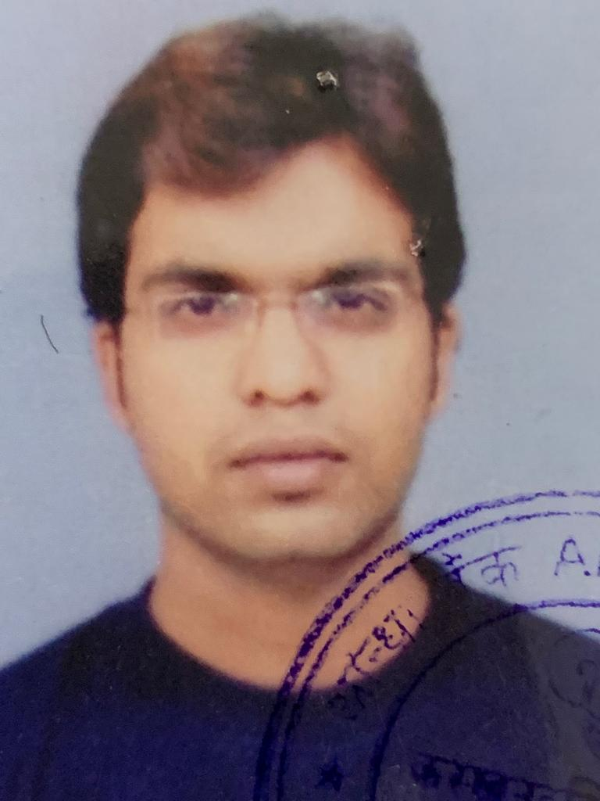
Arun N
Date of Birth: 28-06-1984
Contact Number: 8951766364
Email: arunnatan68@gmail.com

CAREER OBJECTIVE
To pursue a career in a challenging environment where I can best utilize my resources as well as harness my skills and make significant contributions to the growth of the organization I work with.
PERSONAL SKILLS
- Highly passionate and prompt in completing and delivering the task assigned
- Willing to expand my knowledge base and acquire new skills
- Can work and accomplish under pressure and tight deadlines
- Analytical, prioritizing, problem solving and organizational skills
TECHNICAL SKILLS
- Operating System: Windows (7,8,10,11)
- Microsoft Office: MS Word, MS Excel, PowerPoint
- Customer Experience Management
- Major Incident Management
ACADEMIC
- Bachelor’s in hospitality and tourism management from Merit Swiss Asian school of hotel management (2002 - 2005). Secured 70%.
- Diploma in hospitality and tourism management from Merit Swiss Asian school of hotel management (2002 - 2005). Secured 70%.
- 12th (PUC) from S.B.O.A Higher Secondary School, Chennai 2002. Secured 60%.
- 10th (SSLC) from S.B.O.A Higher Secondary School, Chennai in 1999. Secured 65%.
WORK EXPERIENCE
Accenture Services Pvt Ltd (Aug 2022 to Aug 2024)
Incident manager for Microsoft reactive support for multiple contracts assigned under CSAM’S. Handles customer escalations, engineer assignment, review the cases. Participating on bridge calls with customers, Csam and present the case progress and the current status of the tickets.
Incident Manager (Reactive Support Management):
- Manages the process to restore normal service operation as quickly as possible to minimize the impact to business operations.
- Handled 13 contracts global contracts such as Nestle, Hitachi, Fujitsu, Genesys, Figure AI, Open AI etc.
- Responsible for planning and coordinating all the activities required to perform, monitor, and report on the process.
- Provided support on severity cases (P1, P2, P3) cases to achieve the service level agreement.
- Responsible for communicating with the Incident Process Owner.
- Point of contact for all Major Incidents.
- Handled Bridge calls and discussed on the RCA on the issue reported by the customer
- Responsible for the effective implementation of the process "Incident Management" and carries out the respective reporting procedure.
- Represent the first stage of escalation for Incidents.

Concentrix India Pvt Ltd (Oct 2020 to July 2022)
L2 Incident management Technical support team for adobe. Deals with L2 Escalation of the incident management and when required we will also call back the customer and contact them via email to check the issue status.
Senior Technical Support advisor Incident management (Adobe)
- Handle customer query and provide a actual troubleshooting steps based on the issue reported.
- Collaborating with the incident management team to ensure that all protocols are diligently followed.
- Logging all incidents (P1, P2 and P3) and their resolution to see if there are recurring malfunctions.
- Adjusting the incident management process as required to ensure its effectiveness.
- Communicating with upper management if major issues are found in the IT system.
- Managing the incident team members by re-assigning workloads and re-scheduling non-urgent tasks.
Infinite Computer Solutions (Infinite Care Net) JUNE 2016 to Oct 2016
Senior Business Development Analyst (MDE & IBM) Health care provider for Veterans across USA and they had a tie up with the federal department for Veterans Affairs. Infinite care net tied up with an veterans affairs for onetime assessment program for helping veterans in getting their pension and benefits from veterans affairs
Senior Business Development Analyst (MDE & IBM)
- Contacting all the Doctors, Physician back in USA and help them in participating in Health Assessment Program
- Collating all the documents for credentialing and supporting credentialing team
- Also worked in vendor management for IBM
- Collating the information from consultants working for IBM and performed an internal audit
- Worked as a business analyst and fixed an appointment with the providers who wants to take part in the program

Tesco Hindustan Service Pvt Ltd – July 2010 to July 2015
Client Name: Tesco PLC (Retailers) UK based retailers. Worked for direct stack holders
Worked as a senior technical support officer (Contact Centre Lead) and Supported operation starting from service level to team reports such as (FTF, AHT, Outstanding Hrs, End to end resolution and forecasting report for tickets and calls, Quality monitoring etc.)
Worked on tools like ICCM (Ticket Creation Tools) and Crest (Virtual application for checking the system) also have an experience in working store servers by using the same application

Senior Technical Support Officer Incident management
- Handled Level 2 Incident management
- Overseeing the incident management process and team members involved in resolving the incident.
- Responding to a reported service incident, identifying the cause, and initiating the incident management process.
- Logging all incidents and their resolution to see if there are recurring malfunctions.
- Adjusting the incident management process as required to ensure its effectiveness.
- Communicating with upper management if major issues are found in the IT system.
- Managing the incident team members by re-assigning workloads and re-scheduling non-urgent tasks.
CLI3L – e – Services Pvt Limited – Oct 2005 to Oct 2007

Client Name: United Online (ISP Service Provider)
Worked in Sales and billing department as Subject Matters Expert L3 Support (Escalation Specialist). Worked on tool like Remedy (ticket Creation application)
Account history application which helps to get the customer account status and billing screen and also helps us in downgrading the service. And support with the right information for the customer to get in touch with the technical team at times based on the issue we have contact the technical support team.

Technical Support (Incident management)
- Overseeing the incident management process and team members involved in resolving the incident. Handled all process escalation from clients end
- Responding to a reported service incident, identifying the cause, and initiating the incident management process.
- Prioritizing incidents according to their urgency and influence on the business. Appointed as a client call monitoring head for quality team
- Producing documents that outline incident protocols such as how to handle cybersecurity threats or how to correct server failures..

PERSONAL INFORMATION

Date of Birth | 28th June 1984
Languages Known | English, Tamil and Kannada
Address | Villa# 96, Metropolis Fair Oaks, Dodda Thimmasandra, Sarjapura, Bangalore - 562125

