Basavaraj, s.
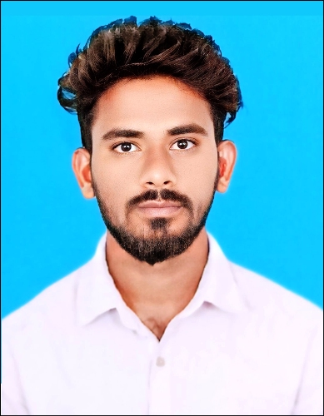
Ph:9972063049
E-maiI id: rajssg33@gmail.com
basavasg39@gmail.com

CAREER OBJECTIVE
Looking for an opportunity to work as an Assistant Librarian which provides professional development, interesting experiences and personal growth.
COURSE | INSTITUTION | YEAR OF PASSING | PERCENTAGE
MLISC (Master of Library and Information Science) | Raichur University Main Campus | 2023 | 6.11 CGPA (First class)
B.A (Bachelor of Arts) | Gulbarga Universrity | 2020 | 65.66 (First Class)
PUC | Hamdard PU College Raichur | 2017 | 66.66 (First Class)
SSLC | KSEEB. Karnataka Raichur | 2015 | 76.80(First Class)

INTERNSHIP
- Successfully completed my internship training from 01/02/2024 to 16/03/2024 at University Library, University of Agricultural Sciences Raichur.

WORK EXPERIENCE
- Librarian- SSRI Training Center Raichur – 5 Months.
- Assistant Librarian - Dr.Chandrasekhar Speech and Hearing Bangalore-1year.

COMPUTER KNOWLEDGE
- I have a good knowledge about the software’s such as paint, Microsoft office programs (word, excel, power-point), Google forms, spreadsheets, Notepad.

SKILLS
- Comprehensive problem solving abilities.
- Good and patient-listener.
- Excellent verbal and written communication skills.
- Quick learner.
- Well-versed in all the Microsoft office applications, and Google forms.
- Capable of maintaining a library.
- Experience in book Accessing, Cataloguing & Circulation of Books.
- Having through Knowledge of Journals Data Entries.

LIBRARY SOFTWARE KNOWLEDGE:
- I have a good knowledge about the software’s such as Koha, E-lib, Easy-Lib, NewGenlib.

- Knowledge in current awareness services by using NewGenlib 3.1version Software.

REFERENCES:

- Dr.G.S.Biradhar.
University Library Chief Librarian
Raichur University Main Campus Raichur
Ph Number:8310791053
Mail ID : biradargs@gmail.com

- Machendra.S
University Library Chief Librarian
University of Agricultural Science Raichur.
Ph Number: 8532 221262
Mail ID : librarian@uasraichur.edu.in
3. Satish Mavin
University Library Assistant Librarian
University of Agricultural Science Raichur
Ph Number:9686157698
Mail ID : satishmavin84@gmail.com

4. K.Narasimhamurthy
Librarian Dr.Chandrasekhar Speech and Hearing-Bangalore
Ph Number: 9620885413
Mail ID : drsrc.librarian@speechear.org

PERSONAL DETAILS:
Name : Mr. Basavaraj
Father Name : Shivalingappa
Date of Birth : 14-06-1998
Permanent Address : At: Gejjibhavi Post: Mustoor
Tq: Devadurga
Dist: Raichur – 584126
Contact No. : 9972063049
Sex : Male
Marital Status : Unmarried
Nationality : Indian
Religion : Hindu

Declaration
I hereby declare that the particulars furnished above true to the best of my knowledge.

Place: (Basavaraj)

