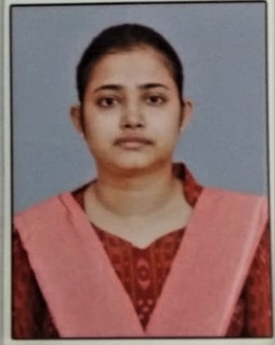
Curriculum vitae

Personal Information
Name:- Sandeepana Satapathy
Email:- sandeepana1996@gmail.com
Phone:- +91-6372536100, +91-8280053190

Professional Summary
Dedicated academic professional with a strong foundation in electrical engineering and a passion for teaching and research. Experienced in mentoring undergraduate students and conducting innovative research in power systems and control engineering. Committed to fostering a dynamic and engaging learning environment.

Work Experience
Working as Pre-primary and Daycare teacher in Little Elly Preschool(17th ,2025 February onwards)
Was Working as an Assistant Professor ( Electrical engineering) Gandhi Engineering College, Bhubaneswar, Odisha[April 2022 – March 2023]
- Delivered lectures and conducted lab sessions for undergraduate courses in Electrical Engineering.
- Supervised students in academic projects and guided them in research methodologies.
- Organized seminars and workshops to bridge the gap between theoretical knowledge and practical applications.

Education
- M.Tech in Electrical Engineering (Power Systems and Power Electronics)
Institute of Technical Education & Research, Bhubaneswar
2019 – 2021 (CGPA:- 9.02)
- B.Tech in Electrical & Electronics Engineering
Institute of Technical Education & Research, Bhubaneswar
2015 – 2019 (CGPA:- 7.18)

Research and Publications
Two-staged (PDF+ 1PI) Controller Design for Load Frequency Control
Published in 2020 International Conference on Computational Intelligence for Smart Power System and Sustainable Energy (CISPSSE), IEEE.

Projects
1. Optimal Controller Design for AGC in Electrical Power Systems Using Artificial Intelligence- Conducted research to develop advanced control methodologies for improving system stability and robustness.
2. Zero Current Switching Using Buck Converter- Investigated techniques to improve energy efficiency in power electronics through zero current switching.
3. Elliptic Filter Design- Designed and implemented high-performance filters for advanced signal processing applications.

Technical Skills
Software Tools:- MATLAB, AutoCAD, MS Office,ECAD
Programming Languages:- C, Java, Data Structures
Control Systems & Power Electronics:** Advanced knowledge in system design and implementation

Certifications
Advanced Control Systems – NPTEL, 2021
MATLAB Programming for Engineers – Coursera, 2020

Languages
- English (Fluent)
- Hindi (Fluent)
- Odia (Fluent)

