
Manish Kumar (Mack)
Mobile : 15519545329
Email : rambo786ranger@gmail.com
Professional Sciense & English Teacher

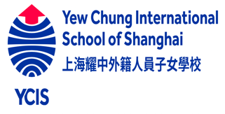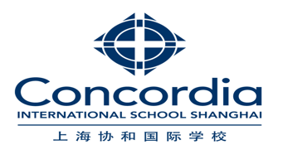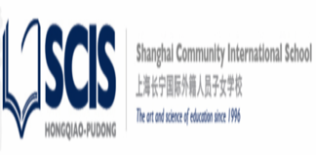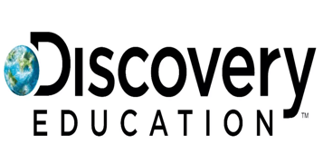
A continuous learner and advocate in the field of science. Professional with 10+ years of experience in science education and practice. Obtained master of science in zoology and also pursuing master of sceience in Physics. Cooperated with top level Shanghai international schools in science curriculum, mentoring and teaching; accumulated deep understanding of science education based on the mutal needs and targets of schools and students. Good presentation skills with strong confidence to get students' admiration.

Professional Experience

Science teacher(stem coach)
YCIS international school, shanghai
SCIS shanghai community international school, shanghai
CONCORDIA international school, shanghai
DULWICH college , shanghai
WELLINGTON college international, shanghai
01/2022- present
English literature Teacher
I.read library
07/2021 - 01/2022
Biology teacher (IB/IGCSE)
UCIS international school, shanghai
07/2020 - 07/2021
Stem teacher
ABIE stem plus school, Hangzhou
02/2019 - 12/2019,
Education Experience
Bachelor of science
Calorx teacher’s university
05/2011 - 05/2014,
India
Master’s in science(zoology)
Calorx teacher’s university
2014-2016
Persuing master’s in science (physics). (2020- PRESENT)
Calorx teacher’s university
American TESOL certification
Capabilities
(as an individual)
- Good verbal and written communication skills.
- Leadership.
- Time management.
- Problem solving & troubleshooting.
- critical thinking
- Disciplined.
- Ability to handle stress and pressure. .
Lesson plan:
- Utilized visual aids and interactive lesson plans to ensure student comprehension/participation in a curriculum containing basic elements.
- Implemented comprehensive lesson plans that promoted positive growth and development to students with behavioral and mental challenges.
- Prepared and documented appropriate lesson plans, based upon adopted curricula, to teach instructional objectives.
- Develop lesson plans, unit plans and educational projects to ensure students academic development.
- Developed and implemented lesson plans to coincide with biology and computer science department curriculum.
Classroom management :
- Performed Classroom management, curriculum design, lesson planning and implementation.
- Gained experience in classroom management, test administration and student discipline.
- Establish acceptable classroom behavior to minimize future classroom management issues.
- Enforce discipline through effective classroom management and parent communication.
Professional development :
- Participated in numerous professional development and collaboration opportunities.
- Provided professional development to educators regarding accommodations and problem solving techniques to apply in crisis situations.
- Participated in rigorous professional development programs to analyze and perfect methods, assessment and standard alignment.
- Attended professional development sessions, communicated with parents, monitored student progress.
- Completed all prescribed activities in accordance with the Professional development plan.
PERSONAL PROJECTS
Blue Bells International School (12/2014 - 06/2017)
Achievements

- Singlehandedly created, developed, and implemented an inclusion module to incorporate students with special needs into a regular educational system.
- Implemented a series of activities based learning programs, which resulted in increased student interest in regular lessons.
- Got the best teacher of the year from the I.read library for excellent performance in 2021
Languages

- English
(Full Professional Proficiency )
- Hindi
(Full Professional Proficiency )
- Chinese
(Professional Working Proficiency)

- Artificialintelligence
- Biology
- Travel
- philosophy
- reading

Interests

