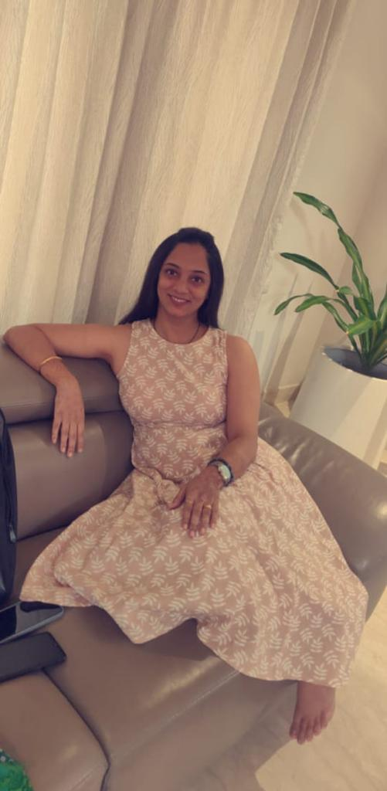 |  | Prajakta Metgud
Profile  Biomedical Engineer  Address : Prajakta Metgud  142, Choodasandra circle,  Huskur post, Hosa Road,  Bengaluru -560099.  Contact  PHONE:  Mobile : +91 – 9148833284  EMAIL:  prajakta8887@gmail.com  Hobbies  - Exploring on home ideas  - Dancing  - Travelling  PERSONAL INFORMATION  - Husband: Mr. Pavan.Akkoji  - Father’s name: Mahantesh.B.Metgud.  - Languages Known: English, Hindi, Kannada, Marathi .  - Date of Birth: 15 Feb 1991 |  | EDUCATION  SSRS  Karnataka State Secondary Education Board  2006 – 2007  78.4%  Chetan PU College  Karnataka State Pre University Board  2007 – 2009  80%  KLE Dr. M.S. Sheshgiri College of Engineering and Technology  Bio Medical:  2010 – 2014  71%  WORK EXPERIENCE- 7.6 years  Seva Medicals Equipment’s PVT LTD [Inside sales Specialist]2014-2016  - Worked as Inside Sales Specialist(Bio medical) and sales Executive for products like Pacemaker (St.Jude company), Heart machine and equipment’s(ICU &CVTS OT products)  - I have extensively familiar with heart devices like ASD (Atrial septal defect),VSD(Ventricle septal defect),PDA(Patent ductus arteriosus).Software based devices.  - Also familiar with Peripheral stents & IVC Filter (Bard company).  VirtusaPolaris [Senior Associate Sales Specialist] 2016-2017  - Worked as Sales Executive engineer in Telecom project in AT&T Project.  - Hands on experience on CRM Tool.  - Business Development Executive.  - Worked on Lead Generation(In-out bound),cold calling,B2B  - Computer skills familiar with (Word, PowerPoint, Outlook, and Excel)  Seva Medical Equipments’sPvt Ltd [Inside sales]2018-2020  - Worked as Sales Engineer (Bio medical) with various products with B2B and Cold calling.  - Worked on sales products for various  - Software based medical Devices to companies like GE, Phillips and Siemens  Orcapod Consulting Services ( Senior Inside sales Specialist ) [from2022 to 2024 March]  - Working as Inside Sales Specialist.  - B2B.  - Lead Generation.  - Cold Calling.  - Recruitment & Staffing.  - Meetings are been conducted through Teams, Google meet.  - CRM Tool is used on daily basis (maintain updates)  - In & Out bound calls are done.  - I have been giving training to joiners for CRM usage and company services.  - Familiar with Excel, PowerPoint, Outlook and Word  - Working for Background Verification Check Services (Accuverse company)  - Working as Inside Sales Specialist for both IT & Non-IT.  Myverkoper Company (Sr Associate at Inside Sales) (started 2024 March to Feb 2025)  - Working as Inside Sales Specialist  - B2B ecommerce platform (cold calling, end to end revenue generation, lead generation and Accounts executive)  AICERTs (Sr Program Advisor)(From 2025 feb to July 2025)  - Worked as Inside sales for B2B market.  - Catering to International clients (Indonesia, Vietnam, Thailand & Philippine region)  - Lead generation, cold calling, emailing  - Strong understanding of Sales and CRM (salesforce and HubSpot)  - Excellent communication, presentation and interpersonal skills.  - Developing quotes and proposals for clients.  - End to end closures handled.  SKILLS  - Hands on experience on CRM Tool.  - Senior Sales Executive at Telecom Domain process.  - Excellent communication, analytical and problem-solving skills and Excellent customer handling skills.  - Business Development Executive  - Sales in software based products.  - Hands on experience on PowerPoint, Word, Outlook  - Handle Daily operations on Client environment.  - Technical process adherence.  - Experience on Training material.  - Hands On Experience on Excel.  - Bridging knowledge gaps in the team.  - Hands on knowledge on Linux, Windows server 2008, 2008 R2, 2012 and 2012 R2.  - Drive team huddles to help the team members understand the process update.  - B2B, Cold calling.  - Inside Sales Specialist.  - Lead generation.  - Recruitment & Staffing.  - In & Out bound calls  - End to end Revenue generation.  - Excellent presentation skills for clients.  CO-CURRICULAR ACTIVITIES  ●Was part of the organizing committee for the annual techno-management fest, “Bio Quench,” held in March 2013.  ●Participated in “Product Analysis Competition” organized by Bio-medical Engineering Department, KLESCET. The event was about creating a virtual company and launching of the pacemaker device. I represented the company’s sales and marketing head.  ●Attended National and International level conferences for orthopedic products.  ●Attended international level workshops at Ruby Hall Clinic Pune on Biomedical Equipment’s and Devices.  ACHIEVEMENTS:  - Worked in IT sector as Senior Executive engineer (Amdocs,Pune).  - Qualified for district level for FOLK DANCE.  - Qualified as an NCC candidate.  - School Prefect in high school.  - Completed successfully hospital survey at “Wanless Hospital, Miraj.”  - Completed successfully hospital training at “KLES’s Dr.PrabhakarKore Hospital, Belgaum.”  - Internship at ”Tech Mahindra” for 1 month. Worked on Labview software .  STRENGTHS:  - Patience.  - Proactive.  - Team player.  - leadership.  COMPUTER SKILLS:  - Packages :MS Office, lyx  - Languages :C, C++, VHDL, SQL  - Assembly languages : Microprocessor 8086, Microcontroller 8051, MSP 430, OMAP based Wipro UTLP.  - Tools : MATLAB, Adobe Photoshop

