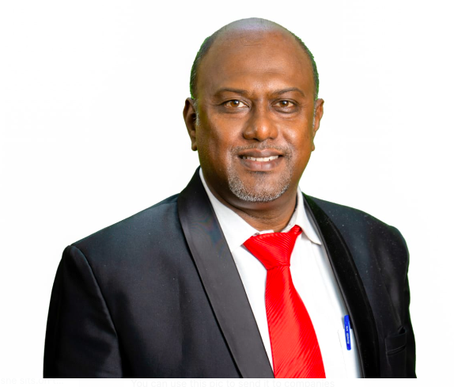
Sunil Maria Benedict
+919900013530; sunilachanblr@gmail.com
No 1, 2nd Cross, Munithapappa Layout, Opposite Banaswadi Railway station,
St. Thomas Town Post, Lingarajapuram, Bangalore – 560084

Objective

Passionate educator with a doctorate in Educational Psychology and a strong literary foundation, seeking a position as an English Teacher and/ or Business studies/ Economics. Experienced in integrating language, literature, and moral values to foster holistic student development.

Education

Doctorate in Educational Psychology - European International University, in association with Asian College of Teachers.

Thesis: Fostering Holistic Development: Integrating Educational Psychology Principles Inspired by Louis-Marie de Montfort in University Settings - Explored how classical devotional texts can promote language development, critical thinking, and moral reasoning in learners - Designed learning frameworks integrating literature with holistic growth.
- MBA in Finance and Marketing with Specializations in Treasury and FOREX, Portfolio and Security analysis, Project Management, Financial Markets and Services, Bangalore University, Year 2000.
- MA in Psychology with specialization in Educational Psychology and Cognitive Psychology, 2023.
- MA in Economics from SGVU, 2024.
- Bachelors in Economics, Political Science and Sociology, St. Josephs College, Bangalore, Year 1998.
- Bachelors in Education, English and Social Science, Indira Gandhi Institute of Higher Education, 2022.
Certifications:
- Cognitive Behavioural Therapy – Practitioner Level from Alison, UK
- Emotional Intelligence in Teaching

Relevant Projects

True Devotion to Mary – A Literary and Educational Psychology Framework
- Developed modules using True Devotion to Mary by Louis-Marie de Montfort to enhance students' reflective writing, comprehension, and moral reasoning
- Created activities linking literary appreciation with English language proficiency

Publications (Amazon)
- Divine Harmony: Chanting the Holy Names of Jesus and Celebrating the Divine Motherhood – Unlocking.
- Devotion to the Lord’s Name: A Catalyst for Social Justice and Harmony
- The Mind of Jesus, According to Saint Luke 15: Mathematical and Linguistic Insights
- Reflections — Mary: The Mother of Purpose (Series 2)

💡 These publications demonstrate my ability to convey complex spiritual and moral concepts clearly and creatively — a key strength in teaching English literature and language.

Skills
- English language instruction (grammar, composition, literature)
- Literary analysis and reflective writing
- Integration of values and moral reasoning in language teaching
- Curriculum design with holistic education focus
- English Language Training (Spoken, Written, Functional)
- Public Speaking & Presentation Skills
- Business Etiquette & Email Writing
- Time Management & Goal Setting
- Personality Development & Grooming
- Active Listening & Empathy Training
- Emotional Intelligence & Growth Mindset
- Lesson Planning & Blended Learning Delivery
- Assessment & Feedback (Rubrics, Reflection)

Additional Information
- Dedicated to promoting holistic learning through literature and language
- Committed to nurturing students' expressive and critical thinking abilities

Professional Experience

Lecturer & Trainer – Communication & Psychology
United International Business School | Bengaluru | April 2024–May 2025
- Conducted training sessions on Soft Skills, Professional English, and Career Readiness.
- Designed modules for Presentation Skills, Interview Readiness, Time Management.
- Mentored students individually for public speaking competitions and debates.
Edufice Education Services Private Limited : Lead - Soft Skills & Leadership Training
Bangalore | August 2022 – March 2024
- Spearheaded the Soft Skills training initiatives across all Undergraduate and Postgraduate programs, aligning modules with industry expectations and NEP 2020 competency frameworks.
- Designed and delivered leadership development workshops focusing on communication, emotional intelligence, goal setting, and personal branding.
- Conducted Skill Enhancement Programs covering public speaking, teamwork, conflict resolution, and workplace readiness.
- Facilitated Project Management training for final-year students using live case studies and interactive simulations.
GrabbnGo Technology India Pvt Ltd, Training Head at BIAL, F&B division
Bangalore International Airport | July 2019 – July 2022
- Leadership & Innovation: Led strategic implementation of automation and convenience-based service systems in the F&B segment, training frontline and supervisory staff in operational adaptability and customer experience best practices. Oversaw end-to-end development, testing, and deployment processes, ensuring teams were continuously upskilled to handle agile implementation, client communication, and cross-functional collaboration.
- Corporate Training & Mentorship: Conducted onboarding and professional development workshops for new hires focused on:
- Business Communication
- Sales training and Customer Delight Strategies
- Corporate Etiquette & Interpersonal Skills - These sessions improved new hire assimilation, reduced onboarding time, and strengthened team culture.
Corporate Trainer (Freelance at Imarticus Training India Pvt Ltd)
Various Clients | March 2015 –July 2022
- Facilitated workshops on Email Etiquette, Voice & Accent Neutralization, and Customer Handling.
- Delivered finishing school programs for engineering and management students.

Instructional Expertise
- Delivery Modes: In-person, Online (Zoom/Google Meet), Blended
- Tools: Google Slides, MS PowerPoint, Canva, Google Forms, LMS (Moodle)
- Pedagogy: Activity-Based Learning, Role Plays, Peer Feedback, Reflection

Key Projects & Achievements
- Trained 200+ final-year students in “Speak to Win” – a public speaking mastery series at CMR University.
- Designed and ran a 30-hour “Professional Writing” bootcamp for business students.
- Contributed to curriculum design for English & Soft Skills programs at undergraduate level.
- Judged multiple intercollegiate debates, and corporate pitch events.

Languages
- English: Native Fluency
- Hindi, Kannada, Tamil: Conversational

