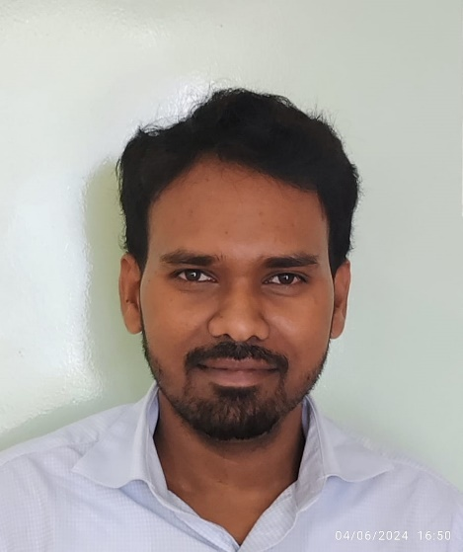

Sudharshan H
sudharshan.h.yadgir@gmail.com
Ph : 9972878026
Bengaluru – KA - 562125

Professional Objective
As a Computer Science graduate with hands-on experience in IT and teaching, I am currently pursuing advanced studies in AI and Data Science. I am eager to contribute my skills while continuing to learn and grow in a dynamic work environment. My goal is to join a forward-thinking organization where I can develop professionally and personally, and make meaningful contributions to innovative projects.

Work History –
Basilwoods international school (09/20 – till present)

- Monitoring Network and firewall, internet bandwidth.
- Helping Students with practical classes
- Hardware and software application related issues
- Smart board issues and maintaining

National Public School Marathahalli (12/2023 - 8/2024)

- MS Office 365 – User Creation, MS Teams Creation/ rules modification
- CCTV configuration and modification
- Active directory and maintaining users(Password reset and creating new user)
- Regularly tracking Bandwidth of Internet and its functionality.
- Addressing Hardware and internet issues.
- Switches and routers and ISP maintain
- Installing MS office and windows.
- Smart board maintaining and regular checking

XpressBees - Bangalore (01/2018 - 11/2023)

- Maintaining IT stock inventory.
- Monitoring and tracking Bandwidth of Internet
- Creating Active directory accounts.
- Providing on time resolution to the tickets.
- Addressing Hardware issues.
- Resolving hardware and software application issues(Laptops and desktops)
- Installing MS office and windows.

Rudra academy - Bangalore (05/2016 - 1/2018)

- Teaching MS office and advance MS office
- Conducted extra classes to help the students to crack the exam.
- Practical class for HTML and Advance MS office(PowerPoint, word and excel)

APWS – ICT Teacher - Bangalore (2015 - 4/2016)

- ICT mentor conducted practical exams to the students.
- Served as ICT primary teacher from Grade Stage 2 to 6.
- Syllabus covered from computer history to basic and till MS office advance.
- Prepared lesson plans for the individual stage. Also based on the learning level of the student.
- Creating worksheets and conducted tests frequently to understand learning level of students.

Hobbies
Art – Oil painting, Glass design
Graphic Designing.
Home tuitions (Computers and Art)

Languages
Kannada, English, Hindi, Tamil and Telugu

APWS – System admin - Bangalore (02/2014 - 2015)

- Implemented corrective plans of action for network performance issues including availability, utilization, and latency.
- Configured, tested and maintained network equipment to achieve
- Resolving connectivity, file sharing and firewall related problems
- Managing network device: switch, wireless modems.
- Providing on time resolution to the tickets.
- Addressing Hardware issues.
- Creating advertising banner / brochure
- Installing MS office and windows.
- Designed school Magazines

Skills

Data analysis
- Tools used : MS excel(Vlookup, Hlookup, pivot table)
- And Jupyter notebook(Python Libraries like Openpyxl, xlwriter Pandas)
- Data analysis
- Data visualization (using tools such as Matplotlib, Seaborn)
- SQL
Programming:
- Python - for data analysis

Cloud computing:
- Have brief knowledge about AWS concepts (EC2, ELB, RDS, S3, Cloudwatch)
Hosting web-apps on EC2 instance

Other skills:
- Wordpress website design
- Microsoft office 365 user management
- Proficient in all Windows OS, - Installing and configuring
- MS-DOS
- MS-Excel, Power point and Word
- Graphic Designing Programs: Blender, Adobe Suite, Corel Draw.

Education

Bengaluru University
Bengaluru
Bachelor of Computer Applications

Projects :
Designed automated system for MIS report. Script used: python,
Libraries used : pandas, openpyxl and numpy Code is at Github.below link. https://github.com/sudarshan0091/MIS-creation-.git

Also created file splitter where different files can be created according to column wise,
Script used: python,
Libraries used : pandas and openpyxl Source code file is in below link https://github.com/sudarshan0091/filesplit

