CURRICULUM VITAE

Mrs.ARCHANA.B
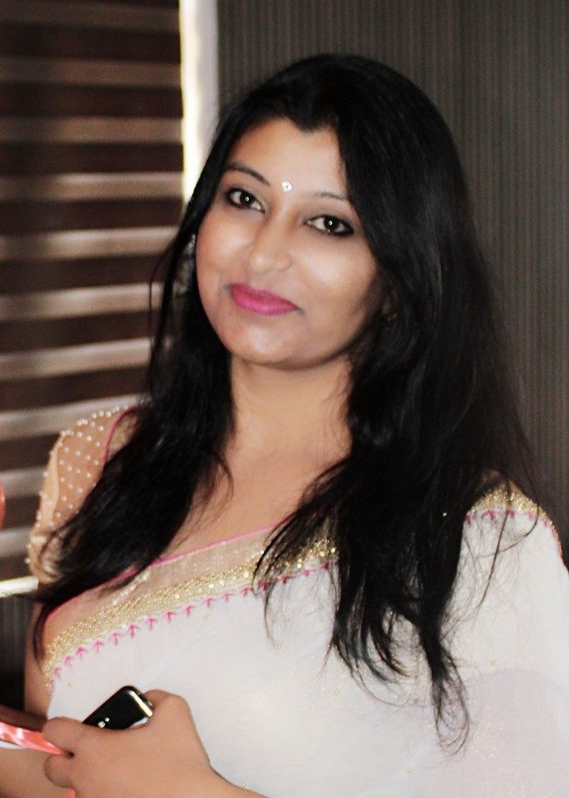  Address:  #101,Anand nagar,  Marathalli,Bangalore  560037  Phone:  9986682313  Email:  archana.kushias@gmail.com  Personal Details:  Date of Birth  17-01-1987  Marital Status:  Married  Nationality:  Indian  Languages Known:  English, Kannada, Telugu, Hindi, Tamil | Objective  Dedicated and experienced lecturer with proven success in my work. Seeking an opportunity to use my decade of experience to serve the reputable organization where I can reach my esteem goals for the betterment of the organization as well as me, without compromising with results.  Educational Qualification  - (PHD) final year  Periyar university  - M.com (Finance)  Bangalore University- June 2009  - B.com (Accounting)  Bangalore university - may 2007  PUC 2004  Department of pre-university education
My Strengths

- Good leadership skills
- Great verbal and written communication skills
- Behavior management.
- Never compromise with end results
- Hard and smart worker.
- Conflict resolution.

Publications work:

- Papers presented in international conference on Banking(KGM)
- Paper presented on financial inclusion (AIMS)

Software skills
- Diploma in computer basics
- Tally 9
Additional Skills
- Worked as a student councilor and cultural head.
- Managed as an alumina treasurer.
- Participated in faculty development program.
- Managed as Academic Programmer .

Experience:

- Worked as a Lecturer in RJS PU AND FIRST GRADE COLLEGE from 2009 to 2012
- Worked as a Lecturer and students counselor in KRUPANIDHI RESIDENTIAL PU COLLEGE, BANGALORE, from 2012 to 2021.
- Worked as Principal in Siri Shrine PU College, Bangalore from April 2021 to till date

Description

From the day one proved with an excellent teaching skills and 100% results each year. To best usage of my strength’s stepping now to words the esteem goals.

Date:
Place: Bangalore (Mrs.Archana. B)

