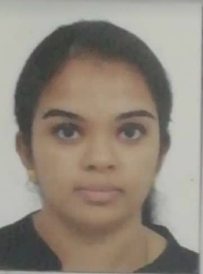  Objective  To build a long term profession as a teacher that will offer endless opportunities for career growth and to keep up with cutting edge educational technologies.  Skills  - Able to inspire and lead others to achieve desired results  - Proven ability to work with senior executives across organisations in a collaborative fashion.  - Disciplined and Time management skills  - Multi-lingual  - German Language B1 Certified  - TEFL/TESOL from APTTI Institute. | Experience  Job Title: Business Analyst (Learning and Development) : Company: Accenture  Dates June –2010 to July – 2018  A result-focused professional with over 8 years of experience in Learning and Development and Client Servicing.  Managed Learning & Development function end to end right from need analysis, organising,  conducting, tracking,Designing Training Agendas, Calendar planning for NGOs and other sessions, Purchase Order raising  Also worked for Voice process for a UK client (Virgin media):  Customer handling (escalation calls)  Monitoring peer calls for quality check.  Education  B.com: Date Earned: 2010 - June : University or College : Baldwins Women's Methodist College (Bangalore University) :  B.Com (Finance specialisation): 65%  German B1 Certified(Goethe Institut)  Pursuing Post graduation Diploma in Education  TEFL/TESOL: Completed 4 module  Volunteer experience or leadership :  Worked for Rotary club Bangalore.
  Name: Pavithra.Kannabiran
  Education and Human Resource| Link to other online properties: Portfolio/Website/Blog

