Name : Ashwini S
Qualification : NTT., DCA., MNT
Mobile : 9741756258, 7483478716
Email : ashwini1992cheery@gmail.com
Permanent Address : TC Halli (V), Dommasandra (po),Anekal (tq), Bengaluru 562125
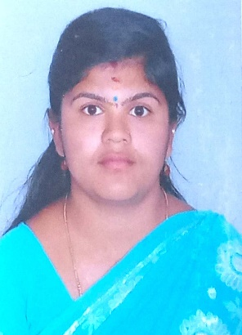
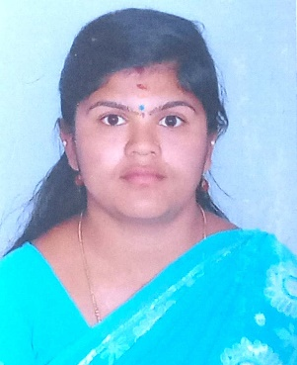

Aiming for a challenging role as a PRE- PRIMARY teacher with a growing institution, to share my talent and to be a part of a dynamic team and gain satisfaction therefore.

PROFESSIONAL SUMMARY:
7 years of successful experience into teaching diverse group of students with an extensive pool of knowledge. Proven track record in handling different situations and making students utilizes the full potential.

July 2015 till date – Endeavour’s International School, Mugaluru (v), Bengaluru, Karnataka
- Work Activity:1. Faculty for PRE- PRIMARY ICSE wing
(At different level Mont 1-3)

RESPONSIBILITIES:
- Cultural event organized for children at different levels.
- Developed the spoken level of children.
- Implemented new methodologies to improve the performance.
- Initiated the needs of institution and students.
- Facilitate good environment and healthy rapport
- Mentor the students for better outcome.

DECLARATION: I hereby declare that the information furnished herein is true and correct to the best of my knowledge and belief.
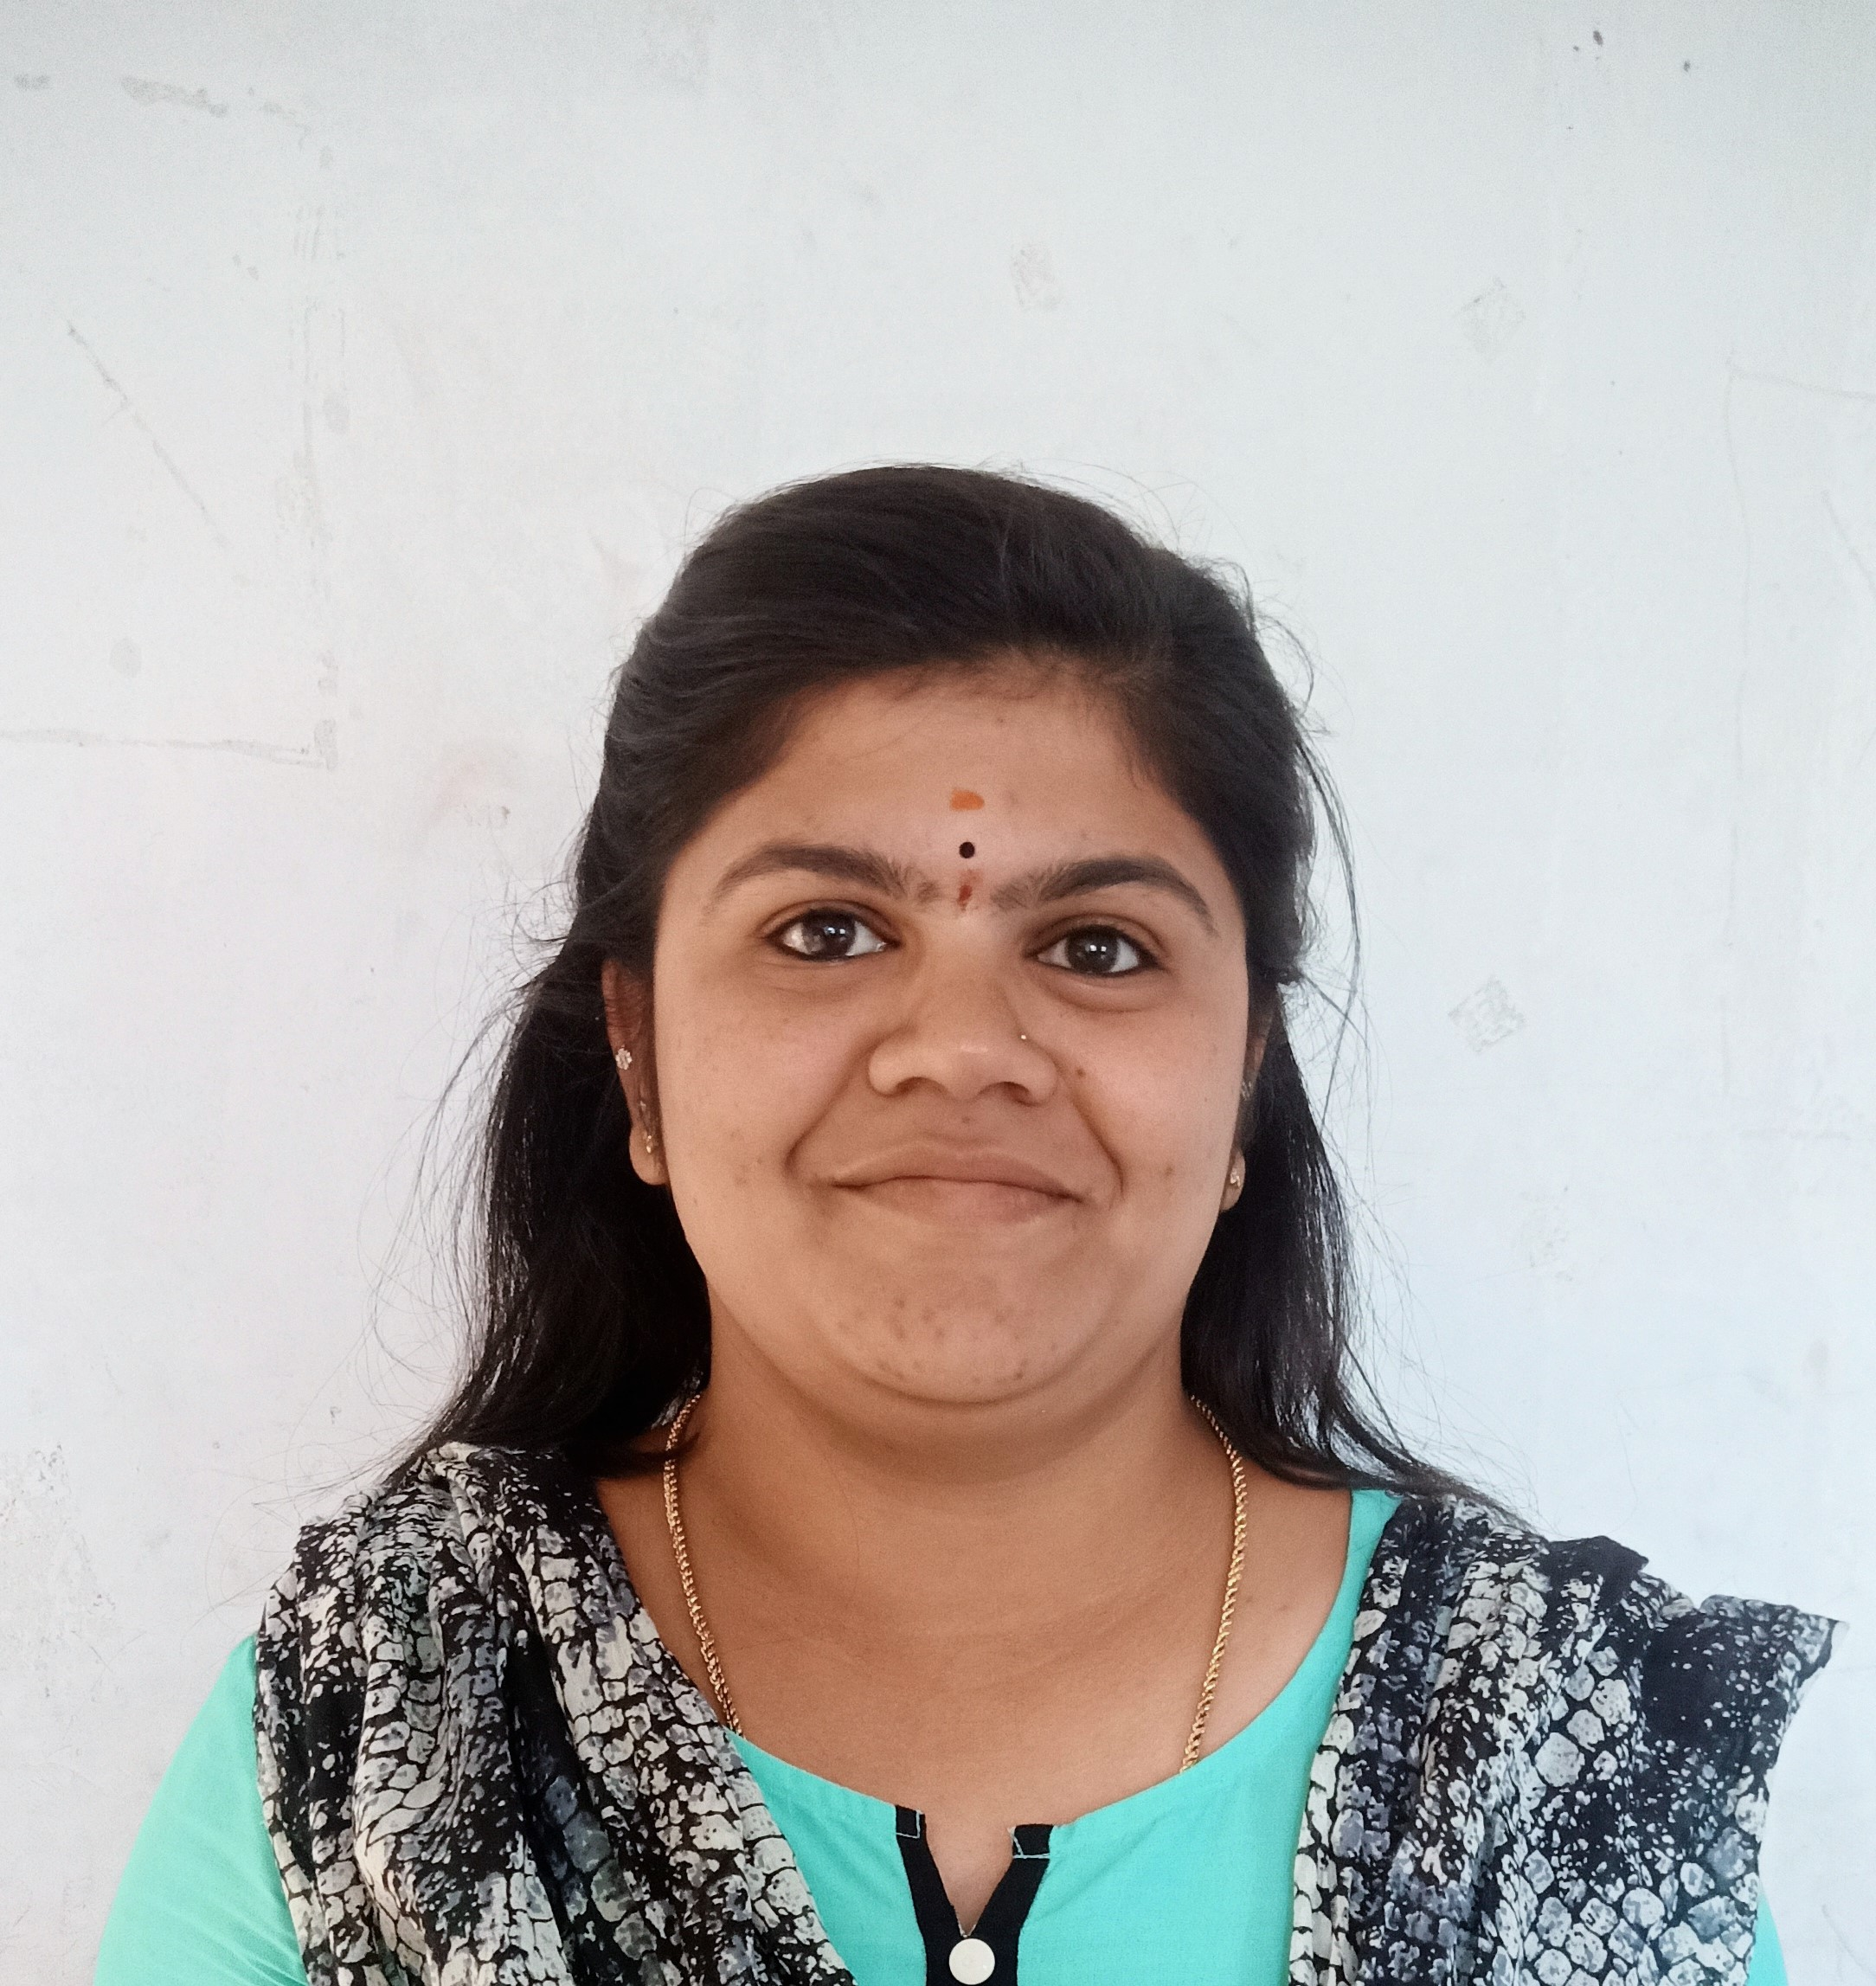

CORE SKILLS:
- Good Communication
- Classroom management
- Student centered instruction
- Creative and caring
- Student discipline
- Event Coordinating

PERSONAL DETAILS:
- Date of Birth : 24/03/1992
- Gender : Female
- Marital Status : Married
- Languages known: English, Kannada, Telugu, Tamil

ACADEMICS:
- MNT from Estherlands Education Institution.
- NTT from Estherlands Education Institution (72%)
- DCA (Diploma in computer Applications) from VIIT (83%)
- SSLC – Dalvoy School, Mysore (60%)

