Sudeshna Sen 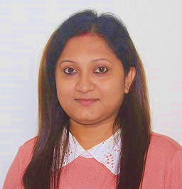

Bavisha Greystone, B. Hosahalli Road (near Sompura Gate), Sarjapur, Bengaluru, Karnataka-562125

sudeshna.dawn1@gmail.com

(+91) 7338131128/ (+91) 9874355074
Caring and motivated Social Studies / Geography teacher with 3.5 years of classroom experience. Strong multitasking ability, recognized for excellent communication skills and ability to manage and enthusiastically engage classes of 35 students. Deeply committed to providing creative educational materials and superior instructional support to create the best.

Work Experience

 The Global Indian International School, Whitefield, Bangalore
CBSE (May 2022 to Present)
As a grade-in-charge subject teacher-
- Preparing ACP (Academic Curriculum Plan) for Grade 7
- Preparing a Broad plan
- Creating lesson plans, worksheets & answer keys
- Planning for the activities and projects
- Making question papers, blueprints & designs for formative and summative assessments as per the CBSE guidelines
As a subject teacher-
- Handling Social Science for 7th and 8th-grade students (Geography, History & Civics)
- Handling Geography for 9th grade
- Delivering the sessions to children as per the plan
- Effectively use different learning resources and platforms provided by the school aligned with learning objectives
- Engage students in inquiry-based learning and project-based learning
- Attending professional training (by CBSE) and workshops organized by the school
- Assigning and grading appropriately classwork, homework, worksheets, tests, and assignments
As a class teacher-
- Working as a class teacher in the 7th grade
- Independently supervising classes of 35 students during arrival and dismissal, mealtimes, on the playground, and on field trips
- Assisting and mentoring students in groups and on an individual basis
- Sending weekly updates to the co-coordinator and principal
- Maintaining accurate and complete records of student’s progress and development
- Educating students on following a school’s moral codes and behaviors
- Planning and organizing assembly events and activities
- Keeping the classroom neat, organized, and orderly
- Create and distribute progress reports to both students and parents
- Conduct parent-teacher meetings to discuss a student’s progress
As an in-charge-coordinator of grade 7-
- Keeping records of students’ details
- Assigning sections based on the student’s 2nd language and 3rd language
- Sending weekly updates to the parents
- Guiding class teachers (7th grade) regarding different issues and informing the coordinator
- Keeping a record of activities done in the classes and uploading it to the drive
- Assigning integrated homework after discussing with the class teacher
- Preparing promotion list across grades
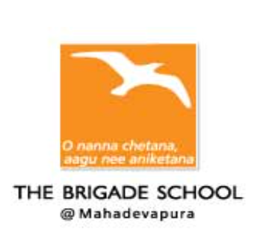The Brigade School, ICSE - May 2020 to March 2022
- Handling Social Science for 6th and 7^{th,} grade
- Delivering the online/offline sessions to children as per the plan
- Preparing PPTs for the subject-related topics
- Assisting and mentoring students during classes
- Preparing Google form question paper
- Sending daily updates to the coordinator
- Attending meetings with Curriculum advisor
- Effectively use different learning resources and platforms provided by the school aligned with learning objectives
- Plan, prepare, and execute continuous informal and formal assessments of students
- Actively plan, participate, and train students for various activities
- Engage students in inquiry-based learning and project-based learning

Sri Sri Ravi Shankar Vidya Mandir, CBSE-August 2019 to January 2020
- Working as a class teacher of 5th standard
- Handling English and Social Science for primary and middle school
- Creating lesson plans, materials, and worksheets as per plan and conducting activities
- Delivering the sessions to children as per plan
- Independently supervising classes of 25 students during arrival and dismissal, mealtimes, on the playground, and on field trips
- Assisting and mentoring students in groups and on an individual basis
- Making question papers as per the CBSE guidelines
- Assigning and grading appropriately classwork, homework, worksheets, tests, and assignments
- Sending weekly updates to the co-coordinator and principal
- Attending professional training and orientation workshops organized by the school
- Maintaining accurate and complete records of student’s progress and development
- Updating home works and exams marks in Coolg
- Writing articles for the school magazine and social media
Educational Qualification
2023- 2024 | Pursuing Masters of Arts in Geography from Singhania University
2023 | B.Ed. from Gear B.Ed. College, Bangalore North University, Secured 1st Class with 87% marks (English & Social Science)
2010 | BA in Mass Communication(H) and Political Science from Maharaja Manindra Chandra College, Calcutta University, Secured first division 1st Class with 61.25%.
2007 | XII (Humanities) from Bramho Balika Sikshalaya, Kolkata, W.B.C.H.S.E Board securing 68% Marks
2005 | X from Sri Ram Krishna Sarada Sangha Balika Vidyalaya, Kolkata, and W.B.B.S.E. Board securing 76.50% Marks with STAR

Other Experience
January 2014 - 2017: Freelance Content Writer
April 2008 –2019: Providing Private Tuitions of ICSE, CBSE, and IGCSE Boards (class 1 to 6- All Subjects)

Achievements
- Awarded with a book for securing the highest marks in B.A(H) in the year 2010 amongst the students of Maharaja Manindra Chandra College.
- Also awarded with a medal for being the highest scorer in Journalism and Mass Communication in the year 2010 from Maharaja Manindra Chandra College

Personal Details
Date of Birth: 31st December, 1988.
Husband`s Name: Mr. Soumya Sen
Permanent Address: 3/4A, Ram Krishna Lane. Baghbazar. Kolkata-700003.
Languages Known: English, Hindi & Bengali.
Hobbies: Internet Surfing, listening to music, dancing & acting.

