Kajal Kumari
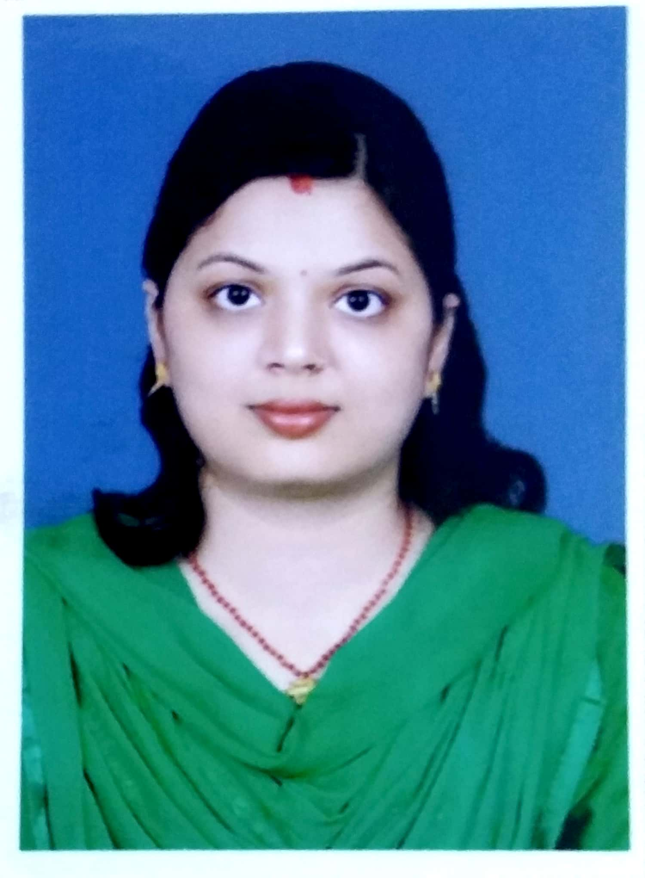
Teaching Professional
- Kadugodi, Bangalore
Experience: 7+ Years
Notice period: Immediate Joiner
+91 968 6719 301
Kajal.Vkgs@gmail.com

Career Objective
Dedicated to teaching mathematics and fostering a deep understanding of math fundamentals in an educational institution.
TET Certification

Teacher Eligibility TEST | TET | Paper | Year of Clearance
Karnataka Teacher Eligibility Test | KARTET | Paper 1 | 2023
Central Teacher Eligibility Test | CTET | Paper 1 | 2023
Bihar Teacher Eligibility Test | STET | Paper 2 | 2023

Teaching Experience
Career Classes, Bangalore
Role: Math Teacher | Duration: Jan 2020 to till date | Board: CBSE, ICSE, and State
Responsibilities
- Instructed mathematics to students in grades 3 through 10 within a group setting.
- Administered unit tests, assessed performance, and communicated results to parents.
- Developed assignments to enhance student learning.
- Implemented chapter-wise assessments, evaluated performance, and provided performance reports to parents.
Prabhat Tara English School, Begusarai, Bihar
Role: Math Teacher | Duration: Mar 2013 to Nov 2016 | Board: CBSE
Responsibilities handled
- Taught math to students in grades 3 through 7.
- Provided counseling and guidance for student development.
- Developed and nurtured age-appropriate skills and social abilities in children.
- Collaborated with colleagues to design lesson plans.
- Managed attendance, student portfolios, and offered individual assistance.
- Conducted Parent-Teacher Meetings to evaluate student progress and provide guidance.
- Established and maintained classroom discipline and good working habits.
- Planned, prepared, and presented inclusive lessons for diverse student abilities.
- Administered exams, graded promptly, and provided constructive feedback.
- Explored and implemented innovative teaching techniques.
- Created effective classroom assessment methods compliant with university standards.

Academic Qualification

COURSE | Month & Year | COLLEGE/UNIVERSITY | Division
B.Ed. (Math & Physical Science) | 2016 – 2018 | New Horizon College of Education, Bangalore | 1st
B.Sc. | Aug 2016 | LNMU, Darbhanga | 1st
12th | May 2013 | BSEB, Patna | 1st
10th | May 2011 | BSEB, Patna | 1st

Method Studied in B.Ed.
- Teaching of Mathematics
- Teaching of Physical Science
- Able to handle Hindi & Sanskrit in absence of subject expert.

Skills

- MS Office (Microsoft Word, Excel, PowerPoint).
- Proficient in delivering impactful presentations.
- Extensive experience in developing working models, study materials, and educational content.

Reference

- Hari Shankar Singh, +91 9431276005 (Principal – Prabhat Tara English School)
- Vikash Kumar, +91 9741073604 (Career Classes)
- Tripurari Maurya, +91 9845927006 (Career Classes)

Personal Details
- Spouse Name : Vikash Kumar
- Gender : Female
- Date of Birth : 16/10/1996
- Marital Status : Married
- Children : Two
- Language Known : English & Hindi (Read, Write, Speak)
- Nationality : Indian
- Hobbies : Reading, Teaching, Travelling

Assurance
I solemnly declare that all the above information is correct to the best of my knowledge and belief.

Date: 27-Jan-24
Place: Bangalore Kajal Kumari

