MADHUMITA DUTTA DEY

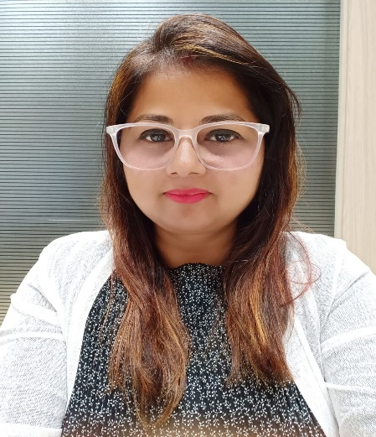

Present Mailing Address : Flat No. – 201. ,2nd floor, Swaminarayan City, Mothagaon, Dombivli West, Dombivli, Maharashtra 421202 ------- madhurav.crm@gmail.com

Interested for relocation with suitable post. (Department – English & Geography). Presently, working as a HEAD & Academic Coordinator of Singhania school. Mumbai.

Having experience with ICSE , CBSE & Cambridge Board

Mob No : 7262805863 / 9372711401
Email : madhurav.crm@gmail.com

Objective: To maximize my potential and utilize my accumulated experience and excellent communicational skills to achieve the aim of organization.

- 28 years of experience in academic field in 08 prestigious national and international organization.
- Passionate of travelling, reading , writing and yoga.
- Excellent communication and inter-personal skills.

WORK EXPERIENCE
___________________________________________________________________________________________________

GAUTAM SINGHANIA GLOBAL SCHOOL – Presently, working as a HEAD & Academic coordinator of Dombivli branch ( Maharashtra) from 1st May, 2023

PODAR INTERNATIONAL SCHOOL ( Kalyan , Mumbai )
Worked since 28th March, 2017 as an English ( Department Head)& Humanities Secondary
teacher. Dealing with – (Cambridge curriculum – IGCSE).
Taking care of admission , training teachers & admin staffs for the spoken English & grooming. Keeping the records of data of staffs in hard copy & soft copy. Maintaining it as per the enrolment.

G.D SOMANI MEMORIAL INTERNATIONAL SCHOOL (Cuffe Parade, Colaba, Mumbai)-
SECONDARY TEACHER cum admission head.(16/08/17- till 25th March )
Worked as a Geography and English teacher in Secondary section.
Even worked as an admission head.

RYAN INTERNATIONAL SCHOOL ( Nerul, Mumbai)
SECONDARY TEACHER& PRO (02/09/16- 10/08/17)
Worked as a teacher of Geography and English to secondary sections.
Even worked as a PRO to deal with parents to solve their problem in regards of their ward.

ORCHIDS INTERNATIONAL SCHOOL ( Masjid Bander, Mumbai)
ADMISSION COUNSELLOR (27/10/14-05/06/16)
Worked in school administration, marketing & training the teachers in over all performance.

DOHA MODERN INDIAN SCHOOL ( DOHA, QATAR)
REGISTRAR and PRO (10 Apr 12 – 17 May 14)

Basic duties :Students admission, issuing certificates & letters to the students. Admission counseling of parents & students, maintaining individual student files, keeping records of school staffs, replying emails related to enquiries from overseas, sending the information of the daily staff absentees to the management, coordinating with the office Heads to update of the students’ record& providing feed back to the parents , maintaining appointment for the parents & teachers meet, dealing with the nurse to give proper information to the parents, sending the daily report e.g. “enquiries, admission, Transfer Certificate issuing number or any accident occurred in the school “ to the management. Assisting the management for meeting agendas. Liaising with the Supreme Education Council, Min. of Qatar regarding uploading of students’ records in portal and compliance of regulations and laws passed by Min. of Qatar.

DAWN INTERNATIONAL SCHOOL (Kochi, Kerala)
CLASS TEACHER & PRO(14/11/2009 – 30/03/2012)

Basic duties : Lesson Plan, conducting Exam, Co Editor of school magazine, organized debates, extempore GD’s, Extracurricular activities for students like art & craft, special class for slow learners. Counseling specially the higher grade students for overall development in social & academic field.

POURA PATHABHAVAN MUNICIPALITY SCHOOL, (Haldia, West Bengal )
ClASS TEACHER and PREFECT INCHARGE PRIMARY DIVISION, (10/05/1999 – 29/06/2009)

Basic Duties: Lesson Plan, Conducting exams, Use of visual media and tangible material for teaching, Imparting awareness and knowledge about society in students though educational excursions, Emphasis on learning by role playing/performing- Helding extempore, debate, GDs, Extracurricular Activities Student’s Assessment though Report Cards and special attention to slow learners, PTAs, Preparing students for inter-school competition, Ensuring cent percent participation, Staff meetings, counseling for overall development of child.

DAV SCHOOL, (BIRATNAGAR, NEPAL)
PRIMARY TEACHER& PRO (15/01/1995 – 27/11/1998)

Basic Duties- recording attendance, organizing student portfolios, provide individual assistance to students. Co-Editor of school magazine. Collecting essay, story, articles and art works from pupils.

Assisted students in preparing models for school exhibition.

QUALIFICATION
___________________________________________________________________________________

MA (Distance Education) : Indira Gandhi National Open University
BEd (English & Social Science): Indira Gandhi National Open University
BA (English Major) : Indira Gandhi National Open University
Teacher’s Training Course : Scribbles and Giggles, Kochi
Higher Secondary(BIEC) : SSNY College, Narpatganj, Araria, Patna University, Bihar

Secondary (ICSE): St. Agnes Convent School, Kharagpur, West Bengal.
Diploma ( Computer Application): Computer Training Institute, Biratnagar, Nepal.
Yoga Instructor Course : S-VYASA,Bangalore

PERSONAL DETAILS
____________________________________________________________________________________
Husband’s Name : Mr. Sourav Dey
Date of Birth : 1st October 1970
Nationality : Indian
Passport Details : No. V7280401 dt.11-02-2022, valid up to 10-02-2032
Languages Known : English, Hindi &Bengali.
Permanent Address : 2/47-B, Vidyasagar, PO-Naktala, Kolkata-700047

