PRIYA DUTTA 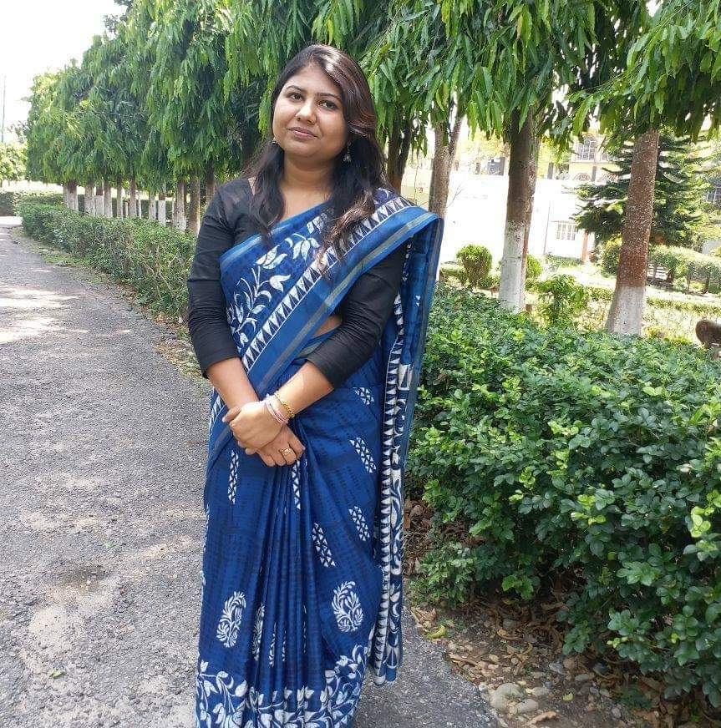

Telephone- 7980719513

E-MAIL- duttapriya54@gmail.com

CURRICULUM VITAE
CAREER OBJECTIVE-
Looking for a challenging job that would allow me to contribute towards the growth and development of my employer institution and would make me self-dependent.
CURRENT STATUS–
ACADEMIC RECORDS
Exam passed | Board | Year of passing | % of Marks
M.sc in Economics | Kalyani University | 2014 | 59%
B.sc in Economics (Honours) | Calcutta University | 2012 | 48.75%
Higher secondary | ISC | 2009 | 85%
Secondary | ICSE | 2007 | 79%
PROFESSIONAL QUALIFICATION
B. ED from CHAUDHARY BANSILAL UNIVERSITY, HARYANA-- SGPA 7.73.
WORKING EXPERIENCE- 8 YEARS.
- PGT ECONOMICS in EURO SCHOOL, WHITEFIELD, BANGALORE- 3RD JUNE- Present.
- PGT ECONOMICS in O.P. JINDAL School, Odisha - August 2022- March,2023
- I have the experience as an Examiner for CBSE class XII paper checking (ECONOMICS), 2022.
- PGT ECONOMICS Teacher in Sai Valley World School, Rourkela, residential school-- April 2020 -14 th August,2022.
- Assistant PGT ECONOMICS teacher as well as residential teacher in Father Leblond School, Siliguri, West Bengal--June 2017 to March 2020.
- Also had the experience of working as the Controller of Examination (COE) for 1 year- 2018-2019.
- PGT ECONOMICS teacher in Sacred Heart School, Moga Punjab- April 2015 to March 2017.
- Internship with State Bank of India
TRAININGS AND WORKSHOPS: -
1. Attended child psychology workshop by UMEED FOUNDATION.
2. Attended effective teaching strategies workshop by SHIKSHANGAN EDUCATION INITIATIVES PRIVATE LIMITED.
3. Workshops conducted by CBSE.
COMPUTER SKILLS-
Basic knowledge of MS word, MS office, MS excel.
KEY SUBJECTS OF INTEREST-
Economics, Statistics, Business studies.
LANGUAGES KNOWN-
Language | Read | Speak | Write
English | Y | Y | Y
Bengali | Y | Y | Y
Hindi | Y | Y | Y

PERSONAL DATA
Date of birth- 24.08.1991
Nationality- Indian
Sex- Female
Marital status- Married
Father’s name- Sudhir Kumar Dutta
Mother’s name- Drazee Dutta
CONTACT INFORMATION: -
Present location- Bangalore
Permanent Address- Sodepur Ghola Manik Danga road, 24 parganas(N), Kolkata- 700111
Extra-curricular activities- *Arts & Paintings
*Singing

