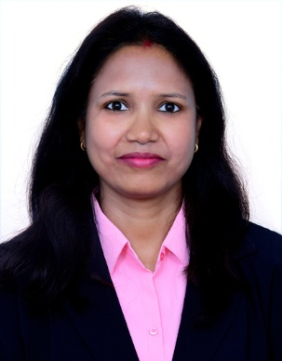  Objective  As a committed, creative, and confident educator, my mission is to nurture problem-solving skills, foster innovative and critical thinking in every child, and ensure the holistic development of each student  Skills  Technical skills:  Languages: Scratch, C, C++,  Javascript, COBOL,  HTML, Data Structure  Others: Microsoft Office, SDLC | Experience  School: St Philomena’s Public School, Sarjapura, Bengaluru  Period: June 2022 to April 2023  As the class teacher, I held responsibility for overseeing the overall academic performance of a group of 20 students. Furthermore, I accepted the responsibilities of teaching Science, General Knowledge, and Moral Stories.  College: Vidyadaan Institute of Technology and Management  Period: Sept 2013 to Dec 2014  As an assistant professor, I taught programming for problem-solving and shared my skills and thoughts with others.  Workshop:  - Training on Networking & Network Management by Nettech, Kolkata in 2013.  - PreDac Course by ACTS, PUNE in 2011.  Education  POSTGRADUATE DIPLOMA IN EDUCATION (INTERNATIONAL). 2023-2024. BIRMINGHAM CITY UNIVERSITY (BCU), UNITED KINGDOM  Currently pursuing  MASTER OF ENGINEERING IN SOFTWARE ENGINEERING. 2011-2013. BIRLA INSTITUTE OF TECHNOLOGY, MESRA, RANCHI  First class with distinction (CGPA 8.19)  BACHELOR OF ENGINEERING IN COMPUTER TECHNOLOGY. 2006-2010. KAVIKULGURU INSTITUTE OF TECHNOLOGY AND SCIENCE, RAMTEK, NAGPUR, MAHARASHTRA  First Class (66.37 %)
  reshma Sinha

