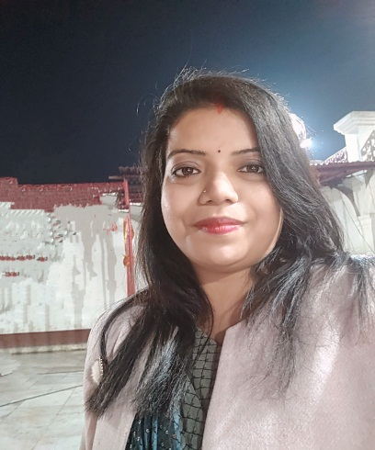
Deepshikha Rai



Bangalore, 562125
7349556356
raideepshikha5@gmail.com

SUMMARY
After a planned break I want to restart my carrie,having 2 years of experience in Recruitment. As a former Hr Recruiter looking for a change in my carrier as per my education I have gained the necessary teaching qualification to allow me to teach the private and the public sectors. As well as the teaching experience gained during my studies, even I have work experience in corporate job also which will help me to understand the needs of students to gain skills and confidence.
SKILLS
- A dedicated and ability to work as individual or as part of team.
- Excellent interpersonal and team skills.
- Management skill.
- Creative and Quick learner.

EXPERIENCE

2. Talific consulting pvt ltd (July 2015 to July 2017)

Designation Sr. HR Recruiter

Roles & Responsibilities:

- Sourcing the candidate from various job portals based on company requirements.
- Experience in using Job Portals like Naukri, Monster, Times jobs & using Social Media recruitment tools like LinkedIn
- To prepare & post the job on recruitment sites.
- Screening the candidate resume and contacting relevant candidate.
- Calling the shortlisted candidates to know their interest about the job opening
- Pre-screening candidates to check their skills, interest level.
- Reviewing the applications, scheduling the interviews of shortlisted candidates.
- Follow- ups with the candidates.
- Convincing employees to attend the interviews.
- After interview sharing feedback with the employee
- Co-ordinate with the candidates till their joining.
- Update all records.

1. Having 1 year of experience as a pre school teacher in Kidzee school (2012-2013)

EDUCATION

Core Qualification:

- Bachelor of Education (B. Ed)
( social science) CRSU Haryana 2018

Certification:

- Three months of Tally 9 (1.0) Accounting course.

- Diploma in computer application from Vendanta Foundation.

Educational Qualification:

- M.A J.P University , Chapra 2013
- Graduation (B.A) J.P University, chapra 2011
- XII (B.I.E.C Patna) Mahendra Mahila College, Gopalganj 2008
- X (B.S.E.B Patna) D.A.V School, Gopalganj 2006
Achievement & Extracurricular:

- Got Quiz certificate at district level
- Participated in Blood donation campaign.
- Achieved Rank 1 in Extempore Competition at district level.
- Leading volunteer in district level functions.

PERSONAL DETAILS:

Husband Name: - Mr. Ravi Kumar Singh
Gender: - Female
Marital Status: - Married
Nationality: - Indian
Language Known: - Hindi & English
Hobbies: - Cooking, Shopping ,Event organizing & Internet Surfing
Strengths: - Extrovert & Optimistic

DECLARATION:

I certify that all the information furnished above is correct and complete. Hope you will consider me
Favorable and give me a chance to prove my ability.

DEEPSHIKHA RAI

- Excellent interpersonal, cross-functional, and leadership skills.

ADDITIONAL INFORMATION
- Painting
- Traveling
- Cooking

