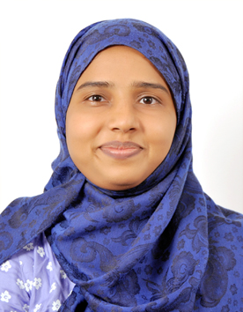
Ahina A
F30, C Block, PSR Aster,
Chambenahalli, Sarjapura, Bengaluru
Mobile No: +91-7411055441
Email id: ahina.ameer@gmail.com

Career Objective:
To begin my teaching career at a well-liked and well reputed institution. I want to achieve good progress in my career through all my best subject knowledge and great teaching effort.

Profile:
- Currently doing a certification course in Teaching English to the Speakers of Other Language (TESOL) at Asian College of Teachers

Skills:
- Excellent communication skill and ability to explain the text
- Ability to dramatize English stories effectively
- Ability to explain word meanings through classroom situations
- Ability to plan, collect materials and deliver the lesson in the class.
- Ability to communicate with parents to report on student behavior, social, and developmental progress

Personal Qualities:
- Making use of different teaching aids for increasing the students interest
- Create a pleasant atmosphere for effective learning

Experience:
- Served as an English teacher for six months in Mother India Senior Secondary School from June 2011 to November 2011 in the classes 2nd, 3rd, 4th and 5th

Academic Qualification:
Qualification | Institution | Year | Score
MA English | Annamalai University, Tamil Nadu | 2012 | 50%
B Ed English | KTCT College of Teacher Education, Kerala | 2010 | 71%
BA English | All Saints College, Kerala | 2009 | 44.9%
Higher Secondary | Sharada Vilasam School, Kerala | 2006 | 81%
Secondary (10th ) | Navabharath Higher Secondary School, Kerala | 2004 | 70.3%

Personal Details:
- Date of Birth: 2nd May 1987
- Languages known: English, Malayalam and Tamil
- Marital Status: Married

