SUMMARY
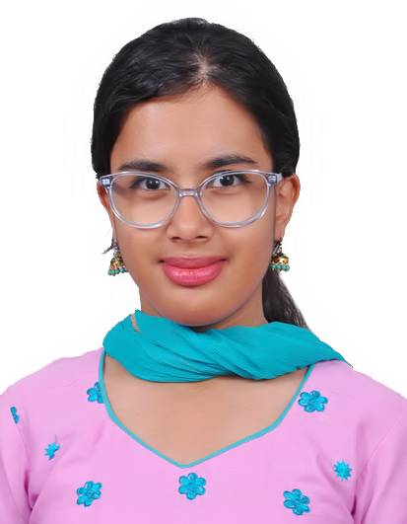

NIKITA NARESH
  - TEACHER
  - CONTACT
  - Phone number: 9513795333

  - Email ID: nikitanaresh181200@gmail.com

  - ADDRESS: B 306, Sri Balaji Monarch, Carmelaram Rly. Stn. Road, Bangalore. 560035

  - Date of Birth: 18 December 2000

  - Nationality: Indian

  - SKILLS AND ABILITIES
  - _______________________
- Good at communication skills.
- Good at creativity.
- Writing – I have written poetry which has been published in various anthologies by various publishers.
- Singing – I have been a part of my degree college choir in the first year and have participated in the Glorious Concert and I am also an active choir member of my church young adults’ group.
- Dancing – I have taken part in an Inter College Dance Competition from my college on behalf of the Hindi Department in Jain university.
LANGUAGES
English, Hindi and Marathi

I am an optimistic forward- thinking teacher willing and able to take the students with stride. I am committed, reliable, dedicated, and hard working with observational and communication skills. I love teaching and most importantly my students who make my teaching fruitful.
EXPERIENCE -INTERNSHIP __________________________________________
1st JANUARY 2023- 31ST JANUARY 2023 PHASE 1
3RD JULY 2023 – 31ST OCTOBER 2023. PHASE 2
St. Francis High School ICSE, Bangalore
I have interned at St Francis High School ICSE for both the phases of my internship. The first phase was in second semester and the second phase was the whole of third semester. I have taught the classes 6th to 8th standard. My subjects are English and Social Science. I have studied the psyche of the students and accordingly design my lessons with power point presentations and activities in the language, literature and geography classes. I begin my class with an introductory activity which helps the students to activate their prior knowledge about the content, the main content is taught with the help of power point presentations and teaching aids which help the students understand the content better, and I conclude the class with question answer sessions, concluding activity or homework which helps the students for assessment of learning. My classes are basically interactive and interesting wherein the students are kept engaged throughout. I create a comfortable learning environment for my students where they are free to express their thoughts and opinions. My students enjoy my classes and I have earned their trust and respect. I have a great rapport with my students which helps me to deal with them on their level which gives way to open communication keeping in mind the limitations and boundaries between teacher and student relationship. My seniors have appreciated my hard work and encouraged me with their positive comments and accolades.

ACHIEVEMENTS
________________________________________________
- Conducted sessions on ‘Stimulation of Brain and Memory’ for the Christ school State students of grade 5 on 29th January 2024.

- Judged state level Essay Writing Competition at Christ School ICSE organized by Karnataka ICSE School’s Association on 19th August 2023.

- As part of service-learning conducted workshop on 1st July 2023 ‘Communication Skills’ under the category of ‘Soft Skills’ at St. Michael’s School where developed a module on communication skills for grades 8 to 12.

- Creativity Activity Service (CAS) an IB course at Kolbe Home under Prison Ministry of India organization. Spent 30 hours 28th February to 4th April 2023 in tutoring underprivileged students.

- Volunteered as a teacher to orient students about the library facilities provided by the university for the event of BOOKMARK from 22nd September 2022 to 24th September 2022 hosted by Christ (Deemed to be University)

Education

__________________________________________
- Aug 2022 - Present Bachelor of Education
Christ university, Bangalore
- Jun 2019 – Apr 2022 Bachelor of Arts
Psychology, Economics and Sociology
Jyoti Nivas Autonomous College, Bangalore
- Jun 2017 - Apr 2019 11th and 12th
History, Economics, Sociology and Psychology
Jyoti Nivas Autonomous College, Bangalore
- Jun 2016 - Apr 2017 10th Class, ICSE
Bethany High School, Bangalore.

