English Teacher with over 13 years of work experience in a reputed CBSE School in Kolkata.
Providing students with exceptional learning opportunities and support of educational endeavors.
Skilled implementor of diverse instruction methods for cultivating fruitful learning environment for all.
Passionate in motivating students with individual guidance and empathetic mentorship.

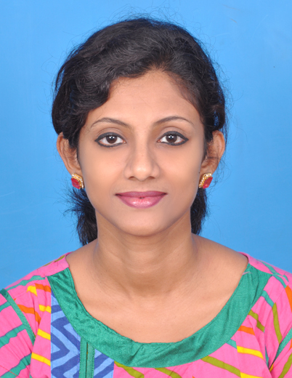

Work Experience
April 2011 to Present
English Teacher
South Point School, Kolkata, India

- Prepared and implemented lesson plans covering required course topics.
- Participated in professional development opportunities to stay up to date on teaching best practices and enhance educator skills.
- Assisted struggling students through targeted interventions, leading to increased academic success.
- Supported students’ skill development in alignment with personal and academic goals.
- Utilized multimedia strategies and technology to convey information in fresh and interesting way.
- Worked with other teachers to support struggling students and provide thorough help to rectify comprehension issues.
- Differentiated instructions to accommodate diverse learning needs ensuring all students had equal learning opportunities.
- Assessed student progress and provided feedback to improve performance and establish academic success.

Personal Details
Date of Birth: 25th July 1985
Marital Status: Married
Religion: Hindu

Skills
- Educational leadership
- Individualized instruction
- Instructional Materials Preparation
- Online instructions
- Digital Media Presentation
- Grading
- Classroom Management
- Parent and Guardian Communication
- SMART Boards
- Curriculum Development

Education
- B. Ed – University of Burdwan
- MA English – University of Burdwan
- BA English (Hons.) – University of Calcutta
- Auxilium Convent School, Bandel, West Bengal

Contact
: PS Srijan Sonargaon, Block 3 Flat 1G, Kamalgazi, Kolkata 700103.
: 9674997761
ramita85@gmail.com

Ramita Ghosh
+91 9674997761
ramita85@gmail.com

