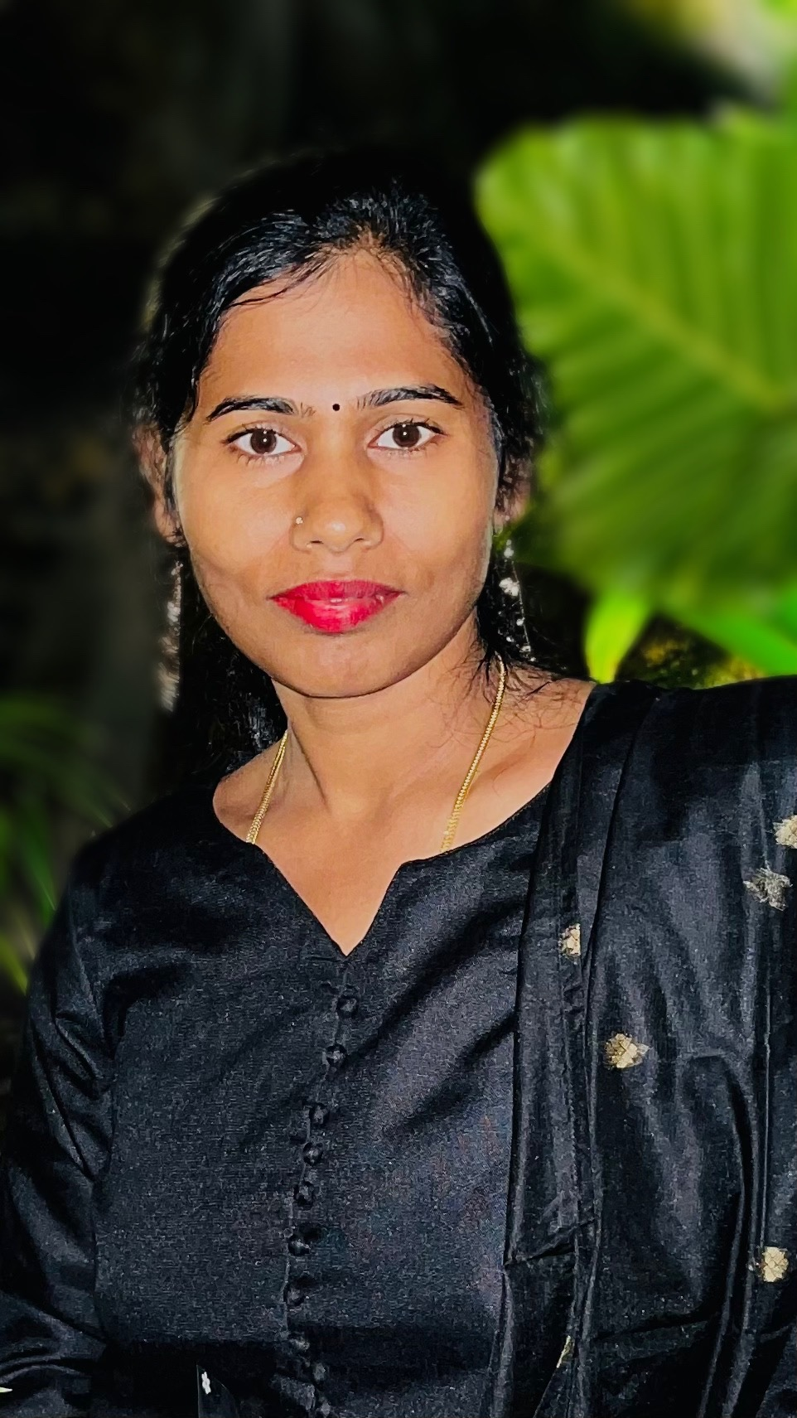 |  | SRIDEVI MADHAVAN  DATE OF BIRTH: 18TH OCTOBER 1982  Nationality: Indian  Marital Status: Married  Languages known: English,Hindi, Tamil
Profile  A positive driven teacher with 14 years of experience, working with students of grades which includes pre- primary,1st-2nd grade, passionate about engaging students on all levels, enhancing their social experiences by encouraging group lessons and learning. Talented and using different teaching methods to reach out to students, including physical demonstrations, drawn  Illustrations and visual presentations.  Contact  PHONE:  9663466665  EMAIL:  msvdevi4@gmail.com  ADDRESS: Villa no. 115, Heritage County, Thindlu Village, Sarjapur Bengaluru- 562125.  SKILLS  - Classroom management  - Technological skills (excel, word, PowerPoint)  - Assessment and Evaluation  - Lesson planning  - Cultural Competence  - Critical thinking and Analysis  - Team Unity and Coordination |  | EDUCATION  Valliammal college for women  Bachelors of corporate secretaryship – 2000-2003  GPA-70%  Vagdevi Vilas School  Pre-Primary teacher training- 2009-2010(Certified by ACT-academy for creative teaching)  Singhania University  Bachelors of Education- 2020-2022  WORK EXPERIENCE  Vagdevi vilas school, Marathahalli [PRE-PRIMARY]  2010–2012  Narayan E-Techno school [PRE-PRIMARY]  2012–2014  Vydehi school of excellence  2014–2024  Experience: 7 years- PRE-PRIMARY UKG [2014-2021]  1 year- Grade 1 [2021-2022]  2 years – Grade 2 [2022-2024]  - Made the Time Table for all the sections of Pre-Primary  - Handled external competitions (SOF, Silver zone, All India drawing and handwriting competitions NASO, NSTSE, Spell Bee)  - Made textbook Reading Materials for Primary Students.  EXPECTATION  Seeking a teaching position that allows me to leverage my skills in primary education supported by a proactive and knowledgeable job provided with tailored job matching, comprehensive application assistance, an environment with a crowd of teachers working with coordination unitedly and insightful career advice.

