CURRICULUM-VITAE

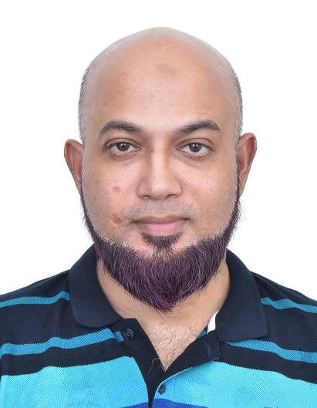

EHTAYSHAM UDDIN KHAN
Computer Science Facilitator

School Teaching Experience: 16 years

Software Trainer Exp: 5 yrs.

College/University

Adjunct-Teaching Faculty Exp: 6 years (in parallel mode)

Email: ehtay786@gmail.com

Contact: 9454202671

TITLE OF RESUME:

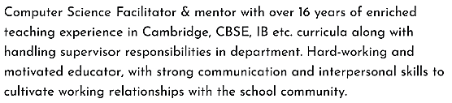
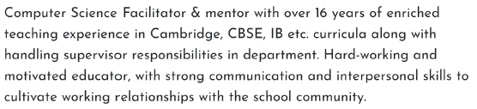

QUALIFICATION:

TEACHING QUALIFICATION

- Completed B Ed. in Computer Science from GLOCAL University(NCTE Approved), Saharanpur, UP, in 2019.

- Alison’s Certificate in Understanding Child Development and Disabilities on 14/02/2022

- Completed course of Teaching English as a Foreign Language, T.E.F.L(120 Hours) qualified

Nov’2020, Teacher Record, owned by Shenzhen Federated Education Technology Co. Ltd.

- Alison’s Diploma in Teaching Skills for Educators Revised-2017, done on 01/04/2020

- Alison’s Certification in “Teaching English as a Second Language”, done on 31st Marc 2020.

TECHNICAL & ACADEMIC QUALIFICATION

- M Phil. in Computer Science from Vinayaka Mission University, Tamil Nadu, 2009-10.

- Master Of Computer Applications(MCA, 65%), IGNOU, 2007

- Advance Diploma in Computer Applications(ADCA, 67%), IGNOU, 2006

- Post Graduate Diploma in Computer Applications(PGDCA, 69%), IGNOU, 2005

- Bachelor Of Computer Applications(B.C.A , 78%), BBDNITM affiliated to Agra University in 2003

- Intermediate (10+2, Science Stream) from H.A.L college in 1999(62%, 1999)

- Matriculation from H.A.L college in 1997(59%, 1997)

WORKING EXPERIENCE (Total Teaching/Administration experience 15 yrs.):

- Currently working as a Secondary Computer Science Teacher in BAARASHU SCHOOL, MOE, Maldives; following Cambridge IGCSE Curriculum.

Time Span: 27 April’21 – till date

- Lastly Served as a Programming Teacher in Debugs Bunny, an Edutech Pvt. Ltd based in Pune.

Time Span: Oct’20 – Feb'21

Responsibilities: Delivering Online classes in Coding domain through online portal to students from Grade 1 to 12.

- Worked as HOD(Comp. Sci.) & PGT(Comp. Sci.) in Syna International School, CBSE Boarding school in Katni, MP-483501

Time Span: Oct'19- Sep’20
Responsibilities: Handling Computer Science subject Grade 6th onwards upto Grade 12th ; Maintaining Computer laboratory with installation and troubleshooting of hardware & networking devices. etc.

- Worked as Senior Java Trainer in a Software Development Firm, ANALYZE INFOTECH. Time Span: Jan'12- Mar 2016

Responsibilities: Handling Computer Science related software training of Core java concepts, servlets, JSP etc., HTML,CSS, JavaScript, C, C++ programming concepts etc

- Worked as PGT (Computer Science) of Navayuga Radiance School, a branch of Navayuga Radiance Senior Secondary School, Sector-G, Jankipuram, Lko. Time Span: July 2007-April 2017

- Worked as a Guest Faculty in Dept. of Computer Application, Khwaja Moinuddin Chishti Urdu, Arabi-Farsi State University, Lucknow

Time Span: 30 July 2015-April 2017

- Worked as a Adjunct faculty in Dept. of Computer Science, Lal Bahadur Shastri Institute of Management Studies, kursi Road, Lucknow

Time Span: Aug 2011-July 2015

COURSES/AWARDS/ACHIEVEMENTS:

- Successfully completed a course titled “Introduction To Bots”, to automate online messaging and conversation services conducted by ALISON's Academy on 29/03/2020.

- Got awarded as Best School Coordinator in conducting International Olympiad “KANGAROO MATHEMATICS OLYMPIAD” held globally in 19 countries altogether in April 2019.

- Conferred with Best Coordinator Award for conducting IOAPCWA’s Olympiad on National level in year 2018.

- Qualified as Sun Certified Java Programmer (SCJP, Core java), a certificate from SUN Microsystems, London, U.K.

- Approved Faculty Member of Lucknow University Panel since 2011

- Approved Faculty Member of K.M.C.U.A.F University Panel since July 2015

TECHNICAL SEMINARS/ CONFERENCE ATTENDED/PARTICIPATED:

- Attended and presented research paper titled ”Role of ICT in Environmental Awareness” in a Two-day National Seminar in KMCUAFU organized by Department of Education, sponsored by UP Government on 02nd - 03rd Mar’16.

- Attended National Conference on Information Security & Software Engineering organized by the University of Lucknow on 10th& 11th March’14 in L.U. campus itself.
- Attended National Seminar on Programming Principles used in Computer Science field organized by Integral University, Lucknow on 20th Dec’13 in its campus.

TEACHERS TRAINING ATTENDED:

 | Plezmo Tech Academy conducted Five- | 4th May – 8th
1 | days |  |  | Webinar Series through Zoom
 | Webinar series in association with Atal | May 2020 |  | Cloud Meeting Platform
 | Innovation Mission, titled as “App/Game
 | Creator Webinar Series”
 | Plezmo Tech Academy conducted Five- | 20th
2 | days | 20th | April | Webinar Series through Zoom
 | Webinar series, titled as “Creator with | 2020 | – 24th | Cloud Meeting Platform
 | Technology Webinar Series” | April 2020
3 | Ten-days online workshop for Teachers | 3rd April 2020 |  | Webinar Series through Zoom
 | conducted by Universal Teachers | – 12th April
 | Academy |  |  | Cloud Meeting Platform
 | from, comprised of following topics:
 | Finding |  | 2020
 | copyright free images; Creation of |  | 2020
 | MindMaps;
 | Digital Brochures & certify; Science
 | Simulation; Creation of E-content &
 | Google
 | Forms
 | Online Session on Gaming Platform | 1st May 2020
4 | organized |  |  | BlueJeans Meeting Platform

 | by Atal Innovation Mission
5 | Capacity Building Workshop on | 19th May, |  | Lucknow Public Collegiate,
 | “Mainstreaming Health & Physical
 | Education | 2018 |  | Ruchi Khand-I, Sharda Nagar,
 | Programme in class IX-XII”, organized
 | by |  |  | Lucknow
 | COE, CBSE
 | Capacity Building Workshop on | 28th July 2018
6 | “Remodeled |  |  | DPS, Indira Nagar, Lucknow
 | Structure of Assessment” for class IX &
 | X,
 | organized by COE, CBSE
 | Workshop on Life skill, Teaching Skills | 26th Feb 2019
7 | & | 26th Feb 2019 |  | Kriti Public School, Barabanki,
 | Motivation organized by Kriti Prakashan
 | Pvt. Ltd., Lucknow |  |  | UP
 | Three days Workshop on Artificial | 18th-20th June
8 | Intelligence, | 18th-20th June |  | CBSE, Bal Bhawan, New Delhi
 | organized by CBSE in partnership with
 | INTEL | 2019
 | Corporation India.

PUBLICATIONS:

- A Research paper titled “Software Quality and Reliability Prediction Modeling” submitted and accepted to be published by Editorial board of Technical journal of LBSIMDS, Vol 8 no. 2 ISSN 0975-2374, july-dec 2016 edition

- A Research paper titled “Influences of Cloud Computing on e-commerce businesses and industry ” submitted by Editorial board of Technical journal of LBSIMDS, Vol 8 no. 2 ISSN 0975-2374, july-dec 2016 edition

- An International referred journal of socio-legal studies, issn: 2320-8562,has published my research paper titled ”Issue based approaches to identifying knowledge requirements”in Jan-July 2016 edition.

- Some other research papers are in pipeline to be finalized and being published.

AREA OF INTEREST:

- J2SE & J2EE

- Operating System Concepts

- Oracle DBMS

- Computer Organization & Architecture

ONLINE CODING PLATFORM USED:

CODE.ORG, SCRATCH, MIT APP PLATFORM

PROGRAMMING & SCRIPTING LANGUAGES KNOWN:
PYTHON, Plezmo Platform, SCRATCH, Java and its packages, C, C++, HTML, XML, CSS, JAVASCRIPT, BASIC, SQL, Visual Basic etc.

WEB BASED TECHNOLOGIES (INTERESTING FIELDS)

- Java Server Pages(JSP)

- Java Servlets

- RMI

- EJB

OFFICE PACKAGE

- MS-Word, MS-Excel, MS-PowerPoint, MS-Access, Open Office

SUMMARY OF STRENGTH:

- Positive and sincere approach towards the responsibilities allotted.

- Good analytical and Communication skills.

- Strictness and dedicated towards the work.

PERSONAL PROFILE:
Father’s Name: | Late Muzaffar Uddin.
Date of Birth: | 14 Jan 1982.
Marital Status: | Married
Spouse Name: | Ms. Afia Zaman
Children: | 2 (Muhammad Izhan Khan age: 7 years, Muhammad Saad Khan:
 | age: 02 years)
Nationality: | Indian
Permanent Address: | ‘Sarwat Manzil’ Near Harooni Masjid Malhore Road Chinhat,
 | Lucknow, UP.

PROFESSIONAL REFERENCES:
- Mr. Nitin Tripathi( Computer Science Faculty, Syna International School, Katni): +917999300187
- Mr Mohd.Waseem(Senior Accountant, KPS, Barabanki): +919450887786
- Mr. Mazhar Uddin(IT Coordinator, CMS, Lucknow): +919452853913

DECLARATION:

I hereby declare that the above-furnished details are true to the best of my knowledge and belief.

Date: Signature

Place: Lucknow

