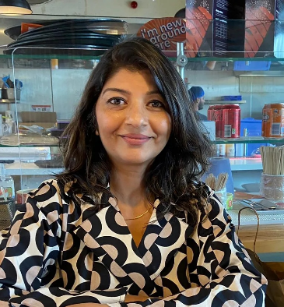
NAME : Vandana Vinayak
DOB : 18th July, 1970
NATIONALITY : Indian
CURRENT ADDRESS : White Town, Pondichery
PERMANENT ADDRESS : GD-49, Pitam Pura, Delhi-110034,

CONTACT NO : 9897420474
EMAIL ID : vandanavinayak18@gmail.com

CURRICULUM – VITAE

With almost 22 years of experience in teaching in Primary and Middle school environments, I believe that I am aware of the various teaching methodologies that would assist children of different age groups and learning abilities to understand and learn keeping with their interest and enthusiasm. I am a learner, looking to grab new and improved ideas every day, to adapt and utilize in my classes. I have also given guidance and assistance to students with learning difficulties like dyslexia and slow learners. I possess a creative attitude and thus, have adapted to various new learning techniques which made my classes challenging, yet interesting for students. Experience in teaching core subjects and ESL (English as Second Language) to Primary and Middle school has been the major part of my professional life.

Objective:
To use my skills and experience and thereby to promote a positive atmosphere, and higher quality education among children. Seeking a challenging and responsible position to use my abilities and experience effectively and efficiently for children.

Education:

- One year certification in SLD (Specific Learning Difficulties) from Alpha to Omega, Chennai -July 2019-20
- M.A (English) – Himachal Pradesh University, 1999
- B.Ed. - M.D University, 1994
- B.A - Delhi University, 1992

Work History:

- EAL teacher with Lycee Française de Pondicherry
(Aug’2018 – Jan’24)
- Content Researcher with 361DM
(Feb’2018 – Aug’2018)
- Grade 5 English teacher with Bina Bangsa School, Jakarta
(July’17- Feb’18)
- Language teacher with Woodstock School, Mussoorie
(April’06 - June’16)
- Middle School language teacher with Spring Dale Sr.School, Amritsar (Sept’03 - Aug’05).
- Elementary School Teacher with Holy Cross Sr.School, Agartala (March’01-June’02)
- Doni Polo NGO School, Tuting, Arunachal Pradesh (May’2000-Dec’2000)
- Primary School Teacher with Blue Bells School, Ahmednagar (January,1999- Feb’00)
- Pre-Primary School Teacher with Angel’s Convent School, Pathankot
(Jan’98-Dec’98)
- Pre-Primary School Teacher with Apeejay School, Delhi
(Jan’97-Aug’97)

AS A TEACHER, I HAVE BEEN-

❖ Planning and providing teaching and learning classes and activities appropriate to the needs of our international student body and in conformity with the school curriculum, preferred teaching strategies, and classroom environment guidelines.

❖ Contributing to the extra‐curricular activities that are an essential part of learning in an international boarding school, like after school clubs (Indian folk dance, India Club, knitting club, Kh-kho and dramatics).
❖ Adhering to the school’s Religious Life Policy.
❖ Contributing to school committees (Indian festival committee) and staff meetings (core staff, junior school all staff meetings and all school staff meetings).
❖ Participate in the life and work of the school (hikes, assemblies, plays, local culture awareness activities).
❖ Participate in annual evaluation, and take advantage of professional development opportunities.

Thanking you,

Vandana Vinayak

