RESUME

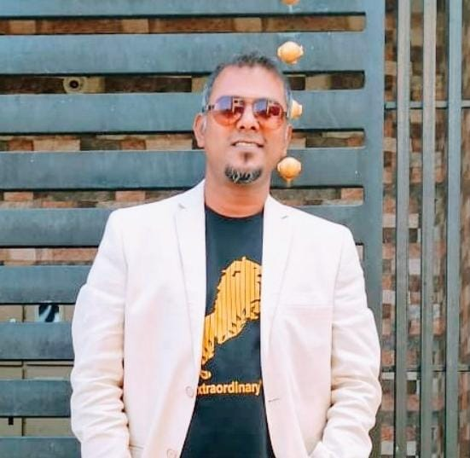

B VIJAYA

Mobile Phone: + 91 8105895568

E-Mail Address: rnvj111@gmail.com

OBJECTIVE

To be a Successful professional in the present biotech scenario, to utilize my skill for innovative methodologies in diverse and progressive programs which in turn will give me a platform to achieve progress and prosperity thus extending selfless service to the society.
PROFESSIONAL SYNOPSIS :

Exceptionally talented Art & Animation Teacher with huge background in teaching students in secondary school the practical skills, theory and history of Art, giving students tuition in aspects such as painting, drawing, print making,
2D &3D Sketching, photography.


PROFESSIONAL EXPERIENCE

Employer : BETHANY HIGH Bangalore Position Held : Art Teacher
Syllabus : ICSE
Duration :2013 to Till Date

Responsibilities:
- Instructed pupils in Art, such as painting, sketching, designing, sculpturing,
- Carving, training children for Board Exam.
- Prepared lesson plans and established course goals.
- Selected books and Art supply for courses.
- Demonstrated method and procedure to pupils.
- Observed and evaluated pupils’ work to determine student progress or to make suggestions for improvement.
- Conferred with student, parent, and counselor to resolve student problem.
- Accompanied students on field trips to museums, Art galleries.
- Directed planning and supervision of student contests and arranging of Art Exhibitions.
- Taught students with disabilities.(NIOS)


Employer : Jain Animation school Position Held : 2D Faculty in Art & Animation
Duration : 3 Years

Responsibilities:
- Undertake general teaching tasks.
- Set up and maintain facilities such as photographic darkrooms, kilns for ceramic work, studios and store areas.
- Order and maintain art resources and materials within the budget allowance.
- Demonstrate the use of a variety of art materials and tools such as oils, watercolors, palettes, brushes, palette knives, pen, pencil, dyes, clay, fabric, canvas, paper, Wood carving, Modelling in 2D Art,
- Inspire students and assist them to develop their creativity and self-expression through various art forms and media.
- Arrange for exhibitions of student work in and out of school.



Employer : ST.FRANCIES DE SALES SCHOOL Position Held : Art Teacher
Syllabus : ICSE
Duration : 2 Years

Responsibilities:
- Undertake general teaching tasks.
- Set up and maintain facilities such as photographic darkrooms, kilns for ceramic work, studios and store areas.
- Order and maintain art resources and materials within the budget allowance.
- Demonstrate the use of a variety of art materials and tools such as oils, watercolors, palettes, brushes, palette knives, pen, pencil, dyes, clay, fabric, canvas, and paper.
- Inspire students and assist them to develop their creativity and self-expression through various art forms and media.
- Arrange for exhibitions of student work in and out of school.

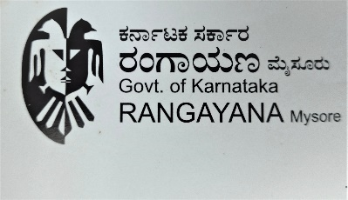
Employer : RANGAYANNA CHINNARAMELA

Position Held : Art Teacher

Duration :3 Years

Responsibilities:
- Undertake general teaching tasks.
- Demonstrate the use of a variety of art materials and tools such as oils, watercolors, palettes, brushes, palette knives, pen, pencil, dyes, clay, fabric, canvas, and paper.
- Inspire students and assist them to develop their creativity and self-expression through various art forms and media.


Employer : CHINMAYA VIDYALAYA SCHOOL Position Held : Art Teacher
Syllabus : ICSE
Duration : 3 Years

- Undertake general teaching tasks.
- Order and maintain art resources and materials within the budget allowance.
- Demonstrate the use of a variety of art materials and tools such as oils, watercolors, palettes, brushes, palette knives, pen, pencil, dyes, clay, fabric, canvas, and paper.
- Inspire students and assist them to develop their creativity and self-expression through various art forms and media.
- Arrange for exhibitions of student work in and out of school.


Employer: Animation Studio

Position Held: 2D & 3D Animator

Duration : 2 Years

Thinxworks produces IP in Stop-motion, 2D Animation and Live-action puppetry, with the objective of creating world-class properties,
helping them package their programs for global audiences.

- Suppandi Series – Animation For Disney & Amar chitra katha

STRENGTHS

- Good team player and flexibility in dealing with a wide range of tasks.
- Ability to work on own initiatives.
- Worked as an Art & Animation Teacher in reputed schools and learn how to deal different kinds of people.
- Good at in Managing students.
- Ability to work in competitive and fast- paced environment.
- Well experienced in organizing School events.
- Good communication skills
- Have good presentation skill.
- Self-Motivated.

ACADEMIC QUALIFICATION

DEGREE /COURSE | INSTITUTION | UNIVERSITY | Years
ANIMATION | Animaster | Bangalore University | 2009
ATC(Art teacher course) | Kannada University Hampi | Kannada University Hampi | 2007
BFA(bachelor in fine arts) | Mysore Educational Board. | Mysore Educational Board. | 2006
PUC | Govt Higher Sec School | TN Educational Board | 2001
SSLC | Govt Higher Sec School | TN Educational Board | 1999

TECHNICAL SKILLS
Computer Proficiency:
- Anime Studio
- Adobe Photoshop
- Adobe Illustrator
- Corel Draw
- 2D Animation
- Max Modeling
- Caricature Art
- Flash
- Basic Computer knowledge.
- Ms-word, Excel, Power point and programming languages.

PERSONAL PROFILE

Father’s Name : Basavaiah
Languages known : English, Hindi, Kannada, Malayalam, Tamil
DOB : 15-04-1982
Mobile : 8105895568
Religion : Christian
E mail Address : rnvj111@gmail.com
Present Address No: 101 M.R Green view apartment
Muthanalur cross, Anekal Hobly

DECLARATION

I hereby declare that above written particulars of information and facts stated are true, correct and complete to the best of my knowledge and belief.

Place: Bengaluru Signature
Date: 24 /06/ 2024
(B.Vijaya )

